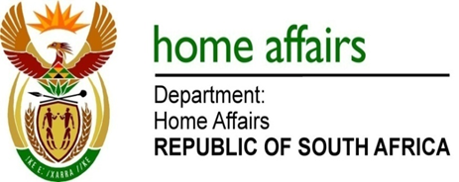

NATIONAL ASSEMBLY

QUESTION FOR WRITTEN REPLY

QUESTION NO. 2491

DATE OF PUBLICATION: Friday, 26 June 2015

INTERNAL QUESTION PAPER 23 OF 2015

2491. Mr C MacKenzie (DA) to ask the Minister of Home Affairs:
(1) (a) What is the total number of applications for unabridged birth certificates that have been received by his department during the period 1 May 2014 to 31 May 2015 and (b) how many applications were received by each (i) regional and (ii) branch office on a monthly basis;
(2) how many of the specified applications for unabridged birth certificates were (a) processed and (b) issued by each (i) regional and (ii) branch office on a monthly basis;
(3) how many applications for unabridged birth certificates can his department (a) process and (b) issue per day;
(4) what is the Key Performance Indicator with regard to issuing unabridged birth certificates in terms of his department’s Annual Performance Plan;
(5) what is the total amount received by his department in respect of applications for unabridged birth certificate applications during the period 1 May 2014 to 31 May 2015? NW2862E
REPLY:
(1)(a) There are 185 641 applications for Unabridged Birth Certificates (UBC) that have been received by the department during the period 01 May 2014 to 31 May 2015.
(1)(b)(i-ii) According to available information the number of UBC applications received and processed during the period 01 May 2014 to 31 May 2015 at the department’s 9 regions / provinces and ready for collection are as follows:
Eastern Cape: 11 408
Free State: 5 589
Gauteng: 75 685
Kwazulu-Natal: 39 952
Limpopo: 4 645
Mpumalanga: 7 401
North West: 4 967
Northern Cape: 2 527
Western Cape: 33 467

(3)(a) The processing of UBC is dependent on the number of applications lodged on a particular day, and is a voluntary process.
(3(b) The issuance per day is dependent on the number of clients that come forth after notification was given to them, via an sms, that the UBC application is ready for collection.
- 6 to 8 weeks.
- 185 641

