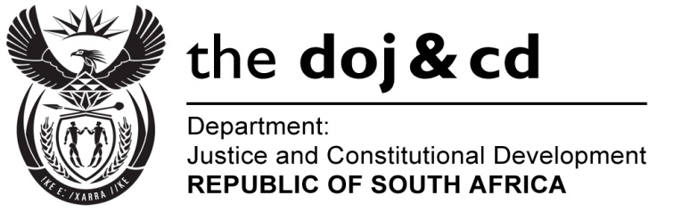

NATIONAL ASSEMBLY
QUESTION FOR WRITTEN REPLY
PARLIAMENTARY QUESTION NO: 249
DATE OF QUESTION: 19 FEBRUARY 2016
DATE OF SUBMISSION: 4 MARCH 2016

249. Mr S P Mhlongo (EFF) to ask the Minister of Justice and Correctional Services:
Whether he and/or his department has bought advertising space in The New Age in the (a) 2012-13, (b) 2013-14 and (c) 2014-15 financial years; if so, (i) what number of times and (ii) for what amount in each specified year? NW253E”
REPLY
The Department of Justice and Constitutional Development has placed advertisements in The New Age Newspaper through the Government Communication and Information Systems (GCIS) (a) 2012/13 and (c) 2014/15.
(b) No advertisement was placed in 2013/14.
- 6 times.
- Total amount of R1 409 452.27 which consists of (a) for 2012/13: R526 906.78; (b) for 2013/14: Nil; and (c) for 2014/15, R882 545.49. Media buying has been centralized at the GCIS to take advantage of bulk buying in terms of cost containment measures.

The National Prosecuting Authority indicated that the NPA placed a recruitment advertisement in the New Age in (b) 2013/14, (i) once (1 time); and (ii) for the amount of R18 400.

The Special Investigating Unit confirmed that the SIU has not placed advertisements in the New Age Newspaper for the financial years mentioned.

