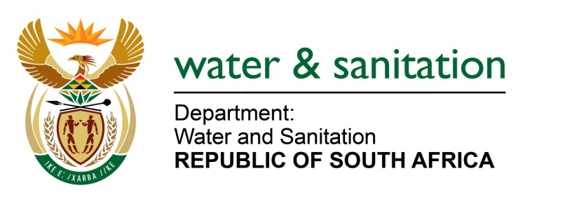

NATIONAL ASSEMBLY

FOR WRITTEN REPLY

QUESTION NO 2488

DATE OF PUBLICATION IN INTERNAL QUESTION PAPER: 26 JUNE 2015
(INTERNAL QUESTION PAPER NO. 23)

2488. Ms T Stander (DA) to ask the Minister of Water and Sanitation:

(1) What is her department doing to enforce the applicable legislation relating to water pollution;

(2) what are the details of each of the water pollution cases her department is involved in with regard to (a) the area, (b) a description of the situation, (c) the environmental impact and (d) the method of intervention? NW2858E
---00O00---
REPLY:
(1) My Department through the Enforcement Unit among other units ensures that all pollution cases reported are investigated and rectification measures are taken where non-compliance is detected.
In instances whereby pollution of a water resource is precisely detected to be occurring or might be occurring, my Department institutes administrative enforcement action prescript in Sections 19 and 20 of the National Water Act, 1998 (Act No. 36 of 1998) (NWA) with the objective of ensuring prevention and remedying effects of pollution and control of emergency incident.
My Department may lay criminal or civil charges against responsible person for unlawfully and intentionally or negligently committing any act or omission which pollutes or likely to pollute a water resource.
My Department also actively participates in the Inter-Departmental Enforcement Task Team comprising of the Department of Environmental Affairs (DEA) and Department of Minerals Resources (DMR) to ensure intensified collective approach against polluters.
(2) Further details cannot be furnished as it may prejudice the outcome of some administrative action and criminal prosecution taken by the Department, which is sub judice according to the National Prosecution Authority.
---00O00---

