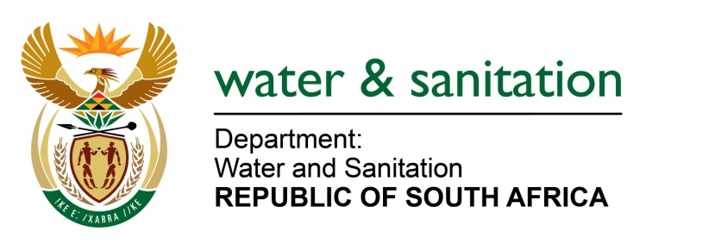

NATIONAL ASSEMBLY

FOR WRITTEN REPLY

QUESTION NO 2485

DATE OF PUBLICATION IN INTERNAL QUESTION PAPER: 26 AUGUST 2022
(INTERNAL QUESTION PAPER NO. 27)

2485. Mr M G E Hendricks (Al Jamah-ah) to ask the Minister of Water and Sanitation:

- Whether he has been advised that (a) residents in Mkhuhlu, Ndubane, Mashonamini, Johnella, Madras and Buyelani in Bushbuckridge are reportedly dying of thirst due to the lack of a water supply and of the danger the situation is posing to the residents of the villages, (b) in 2018, as many as 5 000 standpipes and water meters were installed in the 40 villages in Bushbuckridge, but that the treated water does not reach the reservoir as farmers, residents and residents who recently got land from chiefs unlawfully tap into the bulk water pipe of 62 km, (c) half of the potable water is captured and (d) the municipality says they cannot stop the damage to state infrastructure and theft of water treated at a high cost; if not, what is the position in each case; if so, what are the details of the steps he has taken in this regard;

- whether the residents’ request for a borehole is receiving his attention; if not, why not; if so, what are the (a) time frames that his department has set to act and positively address the request and (b) further relevant details in this regard.

- whether he has found that the Bushbuckridge Local Municipality is failing to provide water to the villages; if not, what is the position in this regard; if so, what are the relevant details?

NW2932E

---00O00---

MINISTER OF WATER AND SANITATION

(1)(a-c)The department has been advised that there are villages that do not have twenty-four hour access to water due to leakages caused by unauthorised and illegal connections, which also impacts the water pressure and adequate supply to villages. The municipality has a rationing programme in place to ensure that all residents have access to water. Bushbuckridge Local Municipality has been advised to implement the water conservation and water demand management and COGTA is part of the Task Team to ensure that it is implemented in order to ensure water availability to communities.

(d) The municipality has a duty to enforce its by-laws by ensuring that farmers and residents that have illegally connected into the water infrastructure are held liable through penalties to curb and regulate water consumption.
- The Bushbuckridge Local Municipality has reported that there are two boreholes supplying villages in the Bushbuckridge area, furthermore, one is functional and the other one in the Buyelani Village, had to be decommissioned due to frequent vandalism. This village receives water through bulk water supply, although it is also impacted by the illegal connections. Once the Hoxani Bulk water scheme is finalised, water supply will improve in the long term.
- As indicated above, the municipality is not able to meet the demand for water supply due to unauthorised connections and water losses. However, there is an ongoing project to replace the asbestos pipeline which is planned for completion in the 2024/25 financial year. The replacement of the asbestos pipeline with a steel pipeline will significantly reduce water losses and improve water supply to the area.

The municipality is also implementing a project to install an additional clear water pump at the Hoxane WTW which will increase the volumes pumped by the plant from 22 Ml/day to 31 Ml/day to the Ndonga reservoir that supplies the villages in Bushbuckridge. The Hoxani Bulk Water Supply Scheme project, which is due to commence at the beginning of 2023/24, will also improve water supply to the villages in Bushbuckridge when is completed. The completion of the Hoxani Bulk water scheme will increase the water supply to full capacity of 36 Ml/day.
---00O00---

