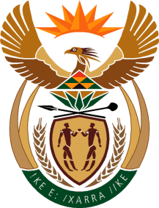

MINISTRY OF TOURISM
REPUBLIC OF SOUTH AFRICA

Private Bag X424, Pretoria, 0001, South Africa. Tel. (+27 12) 444 6780, Fax (+27 12) 444 7027
Private Bag X9154, Cape Town, 8000, South Africa. Tel. (+27 21) 469 5800, Fax: (+27 21) 465 3216

NATIONAL ASSEMBLY:

QUESTION FOR WRITTEN REPLY:
Question Number: 248
Date of Publication: 17 February 2023
NA IQP Number: 2
Date of reply:

Ms H Ismail (DA) to ask the Minister of Tourism:

(1) (a) What (i) did it cost the SA Tourism Board members to travel overseas to discuss the Tottenham Hotspur deal and (ii) total number of board members (aa) travelled and (bb) did not travel and (b) on what basis was the decision taken on which members would travel to discuss the Tottenham Hotspur deal;
(2) whether (a) she and the (b) Deputy Minister were involved in every aspect and discussions with the board on the specified deal; if not, what is the position in this regard; if so, what are the relevant details;
(3) on what date was consensus reached by the SA Tourism board to approve the deal?
NW252E

REPLY:

- (a) (i) I have been informed that travel costs for the four board members amounted to R523 274.97, as indicated in NA PQ 367.

(ii) What total number of board members

(aa) Four (4) board members travelled,

(bb) Seven (7) board members did not travel.

(b) SA Tourism indicated that four members are the chairpersons of the sub-committees of the Board, led by the Chairperson.

- (a) I was not part of any aspect of the discussions as I am new to the portfolio. However, records of the Tourism Portfolio Committee of 07 February 2023 indicate that the former Minister did inform the Committee that she was not involved. Furthermore, the Deputy-Minister indicated that he was not involved.
- 31 January 2023

