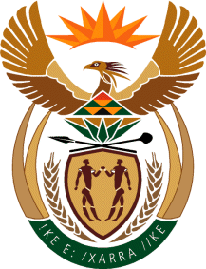
MINISTRY
SPORT AND RECREATION
REPUBLIC OF SOUTH AFRICA

Department of Sport and Recreation l Private Bag X896 l PRETORIA l 0001 l Regent Place l 66 Queen Street l Pretoria l 0001 l +27 (0)12 304 5158 l Fax: +27 (0)12 323 8426
Private Bag X9149 l Cape Town l 8000 l 2nd Floor Parliament Building l 120 Plain Street l CAPE TOWN l Tel: +27 21 469 5705 l Fax: +27 21 465 4402
www.srsa.gov.za
_____________________________________________________________________

NATIONAL ASSEMBLY

WRITTEN REPLY

QUESTION PAPER: No. 29 of 25 AUGUST 2017

DATE OF REPLY: 27 NOVEMBER 2017

2460. Mr. P. G. Moteka (EFF) asked the Minister of Sport and Recreation:
What amount of the department's budget in terms of (a) monetary value and (b) as a percentage of the department's budget is spent in (i) townships and (ii) in areas that used to be within the former Bantustans? NW2717E
______________________________________________________________________

The Minister of Sport and Recreation

REPLY:

The Department of Sport and Recreation South Africa spends its allocated budget against line items such as Compensation of Employees, Goods and Services, Transfers to Provinces and Federations, as well as Capital Expenditure.

The Department’s budget is prepared in line with the common budget template that is applicable to all departments. This template does not provide for the divisions that the Honourable Member is seeking. It will however be of interest to the Honourable Member to note that almost 50% of the departmental budget is a grant that is transferred to provinces. In this regard 40% of this budget is allocated to School Sport and 20% to Club Development. Of these allocations, 50% of it has to be spent in the rural areas.

