NATIONAL ASSEMBLY
36/1/4/1(201900025)

FOR WRITTEN REPLY QUESTION 246
DATE OF PUBLICATION IN INTERNAL QUESTION PAPER: 15 FEBRUARY 2019 (INTERNAL QUESTION PAPER NO 2-2019)

246. Mr S P Mhlongo (EFF) to ask the Minister of Police:

Whether there has been any arrests by the SA Police Service with regard to currency manipulation of the Rand that has been uncovered by the Competition Commission investigation; if not, what is the position in this regard; if so, what are the relevant details?
NW257E
REPLY:

The Directorate for Priority Crime Investigation (DPCI) is not investigating any matter in relation to the currency manipulation of the Rand.

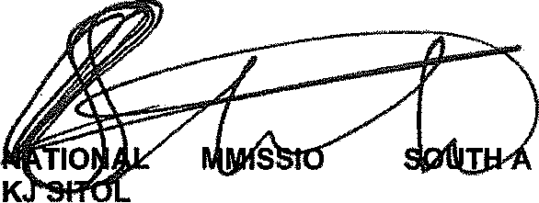
Reply to question 246 recommended/

CO
E (SOEG)

NER:
GENERAL FRICAN POLICE SERVICE

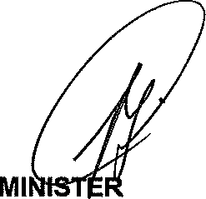
Reply to question 246 approved/

OF POLICE BH CELE, MP

Date: @
/

