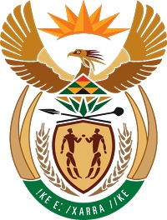
MINISTRY FOR COOPERATIVE GOVERNANCE AND TRADITIONAL AFFAIRS
REPUBLIC OF SOUTH AFRICA

NATIONAL ASSEMBLY
QUESTIONS FOR WRITTEN REPLY
QUESTION NUMBER 2018/2443
DATE OF PUBLICATION: 24 AUGUST 2018

2443. Mr T Rawula (EFF) to ask the Minister of Cooperative Governance and Traditional Affairs:
What is the (a) name of each investing company that has invested on land owned by (i) his department and (ii) each entity reporting to him and (b)(i) nature, (ii) value and (iii) length of each investment?NW2695E
REPLY:

- CoGTA does not own land; its head office is accommodated in five (5) leased buildings acquired through the Department of Public Works.

Land owned by CoGTA.
- None | - Department of Cooperative Governance and Traditional Affairs
- (i) Not applicable | - R0.00 | (iii) 0 hectares

2. SOUTH AFRICAN LOCAL GOVERNMENT ASSOCIATION (SALGA)
(a)(ii) Not applicable
(b) Not applicable
3. MUNICIPAL DEMARCATION BOARD (MDB)
(a)(ii). None, MDB does not own any land nor invested in any land.
(b)None.

4. SOUTH AFRICAN CITIES NETWORK (SACN)
(a)(ii)South African Cities Network is a non-profit organization and has not invested in land.
(b) Not applicable as there are no investments in land.

