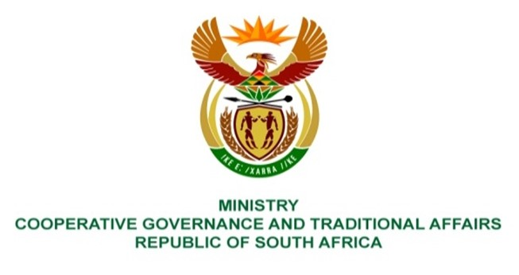

NATIONAL ASSEMBLY
QUESTION FOR WRITTEN REPLY

QUESTION NUMBER 244
DATE OF PUBLICATION: 10 FEBRUARY 2022

QUESTION:

244. Ms A M Siwisa (EFF) to ask the Minister of Cooperative Governance and Traditional Affairs:
In light of the fact that Choseng Secondary School in Ward 3 of Greater Taung Local Municipality was in the Integrated Development Plan (IDP) of the specified municipality in 2011 for the upgrading of existing classes, but to date none has been done, what (a) has she found are the reasons that the IDP of the municipality was not implemented fully and (b) intervention measures is she going to take to ensure future plans of the local municipality include providing the specified school with adequate infrastructure as it was initially in the 2011 IDP? NW257E

REPLY:

The community need on the upgrading of existing classrooms in Choseng Secondary School in Ward 3 in Greater Taung Local Municipality was indicated in the IDP for the 2011/2012 FY but the project was not included in the budgeted list of projects that were implemented by the NW Department of Education for the 2011/2012 Financial Year. However, the following work has been undertaken by the NW Department of Education in the school:
- The school was provided with 6 mobile classrooms (2 were provided in the 2016/2017 FY, an additional 2 in the 2018/2019 FY and a further 2 during the 2021/2022) for a total cost of R666 295,05.
- Extra toilets were provided in March 2021 for a total cost of R401 805,00.
- A Borehole was provided in September 2021 for a total cost of R286 720,00.
The participation of other spheres of government in the IDP processes remains critical. In this regard, the District Development Model is key as a mechanism to ensure alignment of plans across the spheres of government. The DDM is aimed at enhancing cooperative governance through coordinating all three spheres of government to commonly agreed vision and outcomes in a district or metro space. In this regard, DCOG will continue to work with other departments including the Department of Education, provinces and the municipalities in ensuring that the One Plan and the IDPs of municipalities are developed and implemented as part of the implementation of the District Development Model.
Additionally, DCOG has developed Revised IDP guidelines for all municipalities which are aimed at guiding the development and implementation of the IDPs. These guidelines are focuses guiding municipalities on the alignment of the IDPs and the DDM One Plans.

