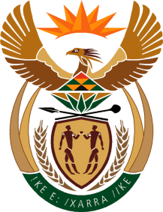

MINISTRY OF TOURISM
REPUBLIC OF SOUTH AFRICA

Private Bag X424, Pretoria, 0001, South Africa. Tel. (+27 12) 444 6780, Fax (+27 12) 444 7027
Private Bag X9154, Cape Town, 8000, South Africa. Tel. (+27 21) 469 5800, Fax: (+27 21) 465 3216

NATIONAL ASSEMBLY:

QUESTION FOR WRITTEN REPLY:
Question Number: 244
Date of Publication: 19 February 2021
NA IQP Number: 2
Date of reply: 31 March 2021

Mr K P Sithole (IFP) to ask the Minister of Tourism:
Whether her department has existing training programmes to capacitate local informal businesses based in the (a) townships and (b) rural areas; if not, why not; if so, what are the relevant details?
NW69E
REPLY:

- And (b) The Department of Tourism provides specific support programmes for both businesses in the townships and rural areas. Informal businesses that approach the Department for assistance are guided to platforms where they can obtain assistance and relevant support packages including being guided on the requisite compliance measures to access such support.

