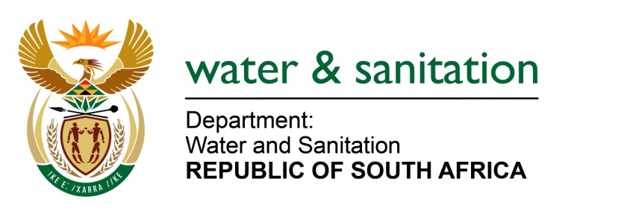

NATIONAL ASSEMBLY

FOR WRITTEN REPLY

QUESTION NO 244

DATE OF PUBLICATION IN INTERNAL QUESTION PAPER: 24 FEBRUARY 2017
(INTERNAL QUESTION PAPER NO. 4)

244. Ms N PSonti (EFF) to ask the Minister of Water and Sanitation:
(a) Why has the community of (i) Sisonke region, (ii) Umkhanyakude sub-region and (iii) the Harry Gwala District Municipality in KwaZulu-Natal been without water for over two years and (b) what is her department doing to ensure that the communities have access to good quality clean water? NW258E
---00O00---
REPLY:

(a) The communities within the Harry Gwala District Municipality (HGDM) and uMkhanyakude DM (UKDM) have been without water for over two years due to two factors, i.e. severe drought impact which has plagued most parts of the KwaZulu-Natal including some of Harry Gwala and uMkhanyakude areas and secondly it has been due to infrastructure limitations in some areas.
(b) The department provides funding to uMkhanyakude and Harry Gwala District Municipalities in order to try to resolve the water challenges faced by the districts and my department will continue to support the municipalities to ensure that the communities have access to good quality clean water.
Refer to the table below for allocations for UMkhanyakude DM (UKDM):
Grant | 2015/16 | 2016/17 | 2017/18 | 2018-19
RBIG | R313 Million | R110Million | R119 Million | None
MWIG | R54 Million | None | None | None
WSIG | None | R70 Million | R50 Million | R65 million
Refer to the table below for allocations for Harry Gwala DM (HGDM):
Grant | 2015/16 | 2016/17 | 2017/18 | 2018-19
RBIG | R14 Million | R48 Million | R90 Million | R100 Million
MWIG | R43.5 Million | None | None | None
WSIG | None | R86 Million | R98 Million | R108 million

---00O00--

