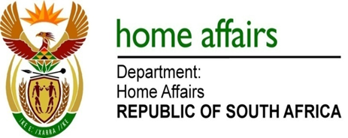

NATIONAL ASSEMBLY

QUESTION FOR WRITTEN REPLY

QUESTION NO. 244

DATE OF PUBLICATION: Friday, 19 February 2016

INTERNAL QUESTION PAPER 2 OF 2016

244. Ms H O Hlope (EFF) to ask the Minister of Home Affairs:

Whether he and/or his department has bought advertising space in The New Age in the (a) 2012-13, (b) 2013-14 and (c) 2014-15 financial years; if so, (i) what number of times and (ii) for what amount in each specified financial year? NW247E

REPLY:

The information is tabulated hereunder:

 | - 2012-13 | - 2013-14 | - 2014-15
(i) | O times | Two adverts - once | One advert - once
(ii) | R0 | R 521,887.44 | R 126,840.96

The placement of the adverts on the New Age Newspaper for the respective years was on the following matters:

2013-14:
- Duplicate ID Case Resolution Campaign
- Government Plan on the Extension of Working Hours During Festive Season at Ports of Entry.

2014-15:
- Multimedia Campaign to intensify Communication on the National Population Registration Campaign (NPRC).

It, however, must be noted that the department has similarly also bought advertising space on the above matters in other newspapers such as The Star and Beeld during the respective 2013-14 and 2014-2015 financial years.

