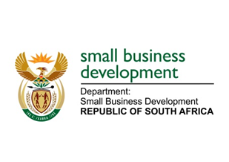
NATIONAL ASSEMBLY
QUESTION FOR WRITTEN REPLY
2435. Ms T Gqada (DA) to ask the Minister of Small Business Development:

What amount did (a) her department and (b) each entity reporting to her spend on advertising in (i) Sowetan and (ii) Daily Sun in the (aa) 2012-13, (bb) 2013-14 and (cc) 2014-15 financial years? NW2801E

REPLY:

(a) The Department of Small Business Development did not spend any amount on advertising in (i) Sowetan and (ii) Daily Sun since its inception.

(b) The Small Enterprise Finance Agency (sefa)

Sefa did not spend any amount on advertising in (i) Sowetan and (ii) Daily Sun in the (aa) 2012-13 financial year.

Sefa spent R45 280 and R48 963 on advertising in (i) Sowetan and (ii) Daily Sun in (bb) 2013-14 financial year respectively.

Sefa did not spend any amount on advertising in (i) Sowetan and (ii) Daily Sun in the (cc) 2014-15 financial year.

(b) The Small Enterprise Development Agency (Seda)

Seda spent R421 309.80 and R821 370 on advertising in (i) Sowetan and (ii) Daily Sun in the (aa) 2012-13 financial year respectively.

Seda spent R271 351.66 and R194 438.40 on advertising in (i) Sowetan and (ii) Daily Sun in the (bb) 2013-14 financial year respectively.

Seda spent R204 070.60 and R239 260.18 on advertising in (i) Sowetan and (ii) Daily Sun in the (cc) 2014-15 financial year respectively.

