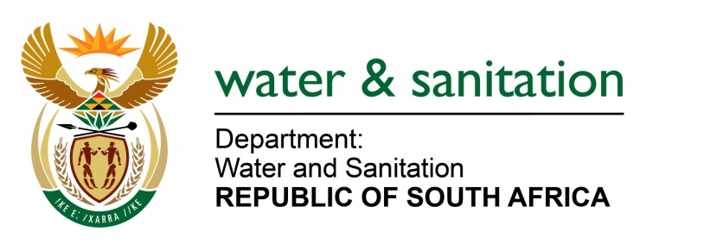

NATIONAL ASSEMBLY

FOR WRITTEN REPLY

QUESTION NO 243

DATE OF PUBLICATION IN INTERNAL QUESTION PAPER: 24 FEBRUARY 2017
(INTERNAL QUESTION PAPER NO. 4)

243. Mr P G Moteka (EFF) to ask the Minister of Water and Sanitation:

With regard to the community of Mamone in Ward 21 and 20 in the Makhuduthamaga Local Municipality in Limpopo, which has not had water in their taps since August 2016, (a) why does the specified community not have water and (b) by what date will she ensure that there will be water in the taps of this community? NW257E
---00O00---
REPLY:

(a) Mamone Ward 20 and 21 in Makhuduthamaga has not had water since January 2017 and not since August 2016 as it is indicated above. This is due to two boreholes that are not functioning. The two boreholes are not functional due to operations and maintenance issues. In one of the boreholes, pipes have collapsed and are submerged and need to be fished and replaced. In another borehole, a submersible pump motor was burnt during drought as the water flow yields were low. The third borehole that is functional is not yielding enough flow and, as a result, not everyone is able to get water.
(b) The Sekhukhune District Municipality (SDM), being the Water Services Authority (WSA); has engaged in a procurement process to replace of equipment for the refurbishment of the two boreholes which are expected to be functional by end of March 2017.
---00O00---

