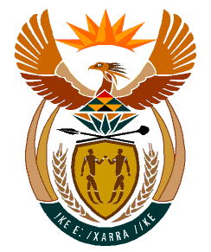

MINISTRY
HUMAN SETTLEMENTS
REPUBLIC OF SOUTH AFRICA

Private Bag X645, Pretoria, 0001. Tel: (012) 421 1309, Fax: (012) 341 8513

Private Bag X9029, Cape Town, 8000. Tel (021) 466 7603, Fax: (021) 466 3610

NATIONAL COUNCIL OF PROVINCES
QUESTION FOR WRITTEN REPLY
QUESTION NO.: 2425
DATE OF PUBLICATION: 20/06/2022

2425. Mrs S. M. Mokgotho (EFF) to ask the Minister of Human Settlements:
On what date is it envisaged that her department will provide adequate housing for the community of Clarens in Thabo Mofutsanyana District Municipality in the Free State, which has been promised housing since 2007? NW2851E
Reply:
Based on information provided by the Dihlabeng Local Municipality is currently finalizing various township establishment projects in Clarens, whereafter the sites will be made available to qualifying and approved households.

