FOR WRITTEN REPLY QUESTION 2425

NATIONAL ASSEMBLY
36/1/4/1(201800235)

DATE OF PUBLICATION IN INTERNAL QUESTION PAPER: 24 AUGUST 2018 (INTERNAL QUESTION PAPER NO 26-2018)

2425. Mr D W Macpherson (DA) to ask the Minister of Police:

With regard to the (a) Umhlali Police Station and (b) KwaDukuza Police Station, what is the total number of firearms that have been (i)(aa) stolen from members and (bb) lost by members since 1 January 2014 and (ii) recovered since 1 January 2014?
NW2673E
REPLY:

(a) Umhlali Police Station.
(1 January 2014 to date)
(i)(aa) Stolen from members | = | 3
(i)(bb) Lost by members | = | 0
(ii) Recovered | = | 0
(b) KwaDukuza Police Station. (1 January 2014 to date) (i)(aa) Stolen from members | = | 8
(i)(bb) Lost by members | = | 1
(ii) Recovered | = | 2

Response to question 2425 recommended/

GENERAL
NE
E (SOEG)
UTH AFRICAN POLICE SERVICE

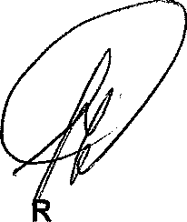
Response to question 2425 approved/

MINISTE OF POLICE BH CELE, M

Date: /

