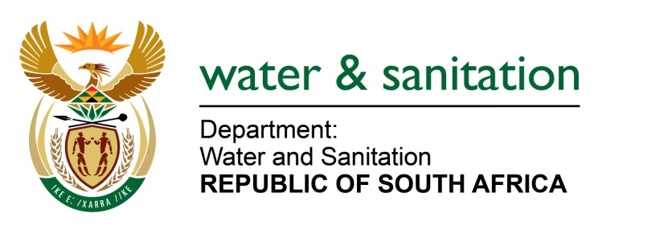

NATIONAL ASSEMBLY

FOR WRITTEN REPLY

QUESTION NO 2424

DATE OF PUBLICATION IN INTERNAL QUESTION PAPER: 17 JUNE 2022
(INTERNAL QUESTION PAPER NO. 24)

2424. Mr T M Langa (EFF) to ask the Minister of Water and Sanitation:
On what date is it envisaged that his department will assist with providing an adequate water supply to the residents of Tongaat in KwaZulu-Natal, whom have been without water since the floods?
NW2850E
---00O00---

MINISTER OF WATER AND SANITATION

The Department of Water and Sanitation (DWS) established a WAR room to assist the Ethekwini Metro Municipality to manage the impacts of the floods on water services provision, on 15 April 2022. Officials of the DWS are members of the WAR room and are monitoring interventions to ensure water services are restored and alternative water supplies provided.

The Ethekwini Metro has appointed a contractor to reinstate the Tongaat Water Treatment Works (WTW). The construction is scheduled to be complete and the works commissioned by 30 September 2022.

In the interim the Ethekwini Metro is providing water via approximately 20 water tankers and 33 static tanks installed in the Tongaat area.

Some parts of Tongaat including Watsonia, Buffelsdale, Mithanager, Trurolands, Gandhinagar, Chelmsford Heights and parts of Tongaat Central that are supplied from the Tongaat South Reservoir, are receiving water for a few hours a day.

Other parts of Tongaat that are receiving water from alternative systems include parts of Belvedere area, Raj Kumar’s farm areas, Walter Reid Road, Amanzimnyama area, Brake Village, Plain Street and parts of the Gandhinagar area.

---00O00---

