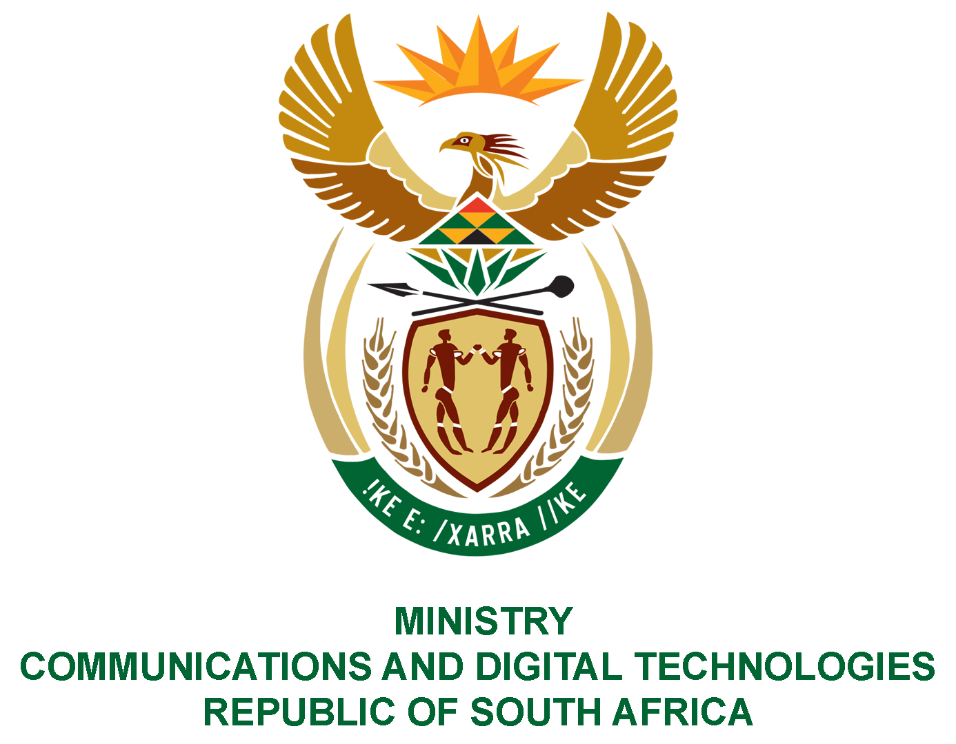
PARLIAMENT OF THE REPUBLIC OF SOUTH AFRICA
NATIONAL ASSEMBLY
WRITTEN REPLY

QUESTION NO: 2424
DATE OF PUBLICATION: 23 OCTOBER 2020
QUESTION PAPER NO: 40
DATE OF REPLY:

Ms PT van Damme (DA) to ask the Minister of Communications:

1. What total number of (a) national and/or provincial departments, (b) municipalities and (c) state entities owe money to the SA Broadcasting Corporation (SABC);
2. what is the name of each specified (a) department, (b) municipality and/or (c) state entity that owes money to the SABC;
3. (a) what total amount is owed in each case, (b) what is the nature of each specified debt, (c) for how long has each debt been outstanding and (d) what plans are in place to recover each debt owed? NW3032E

REPLY:

I have been advised by the SABC as follows:
1. Government departments owe money to two divisions of the SABC that is TV Licences and Advertising. The following is in accordance with the TV Licence database:
(1)(a) A total of 20 National departments have outstanding TV licence fees balances. 126 Provincial departments have outstanding licence fees,
(1)(b) A total of 249 municipality accounts owe television licence fees
(1)(c) A total of 57 SOEs have outstanding TV licence fees on their accounts.

The following with regard to SABC Sales (Advertising):
National Department: 3
Provincial Departments: 24
Municipalities: 6
SOEs: 8

(2)(a) National/Provincial Departments
Department | Segments | Province
Government Communications | National | National
National Department of Health | National | National
Department of Trade and Industry | National | National
Department of Education Polokwane | Provincial | Limpopo
Free State Department of Health | Provincial | Free State
KZN Department of Health | Provincial | Kwa-Zulu Natal
Department of Education and North West | Provincial | North West
Eastern Cape Provincial Legislature | Provincial | Eastern Cape
Free State Department of Provincial Treasury | Provincial | Free State
Department of Health North West | Provincial | North West
KZN Department of Transport | Provincial | Kwa-Zulu Natal
Department of Public Works Polokwane | Provincial | Limpopo
Department of Community Safety and Liaison | Provincial | Kwa-Zulu Natal
Department of Co-operative Governance - KZN | Provincial | Kwa-Zulu Natal
Kwa-Zulu Natal Education Department | Provincial | Kwa-Zulu Natal
Department of Health Mmabatho | Provincial | Kwa-Zulu Natal
The office of the Premier KZN | Provincial | Kwa-Zulu Natal
KZN Provincial Treasury | Provincial | Kwa-Zulu Natal
Premiers Office Mpumalanga | Provincial | Mpumalanga
Eastern Cape Provincial Treasury | Provincial | Eastern Cape
North West Legislature | Provincial | North West
Department Sport, Art and Culture - Mpumalanga | Provincial | Mpumalanga
Department of Human Settlements KZN | Provincial | Kwa-Zulu Natal
Department of Agriculture KZN | Provincial | Kwa-Zulu Natal
Department of Social Development KZN | Provincial | Kwa-Zulu Natal
Department of Agriculture Mpumalanga | Provincial | Mpumalanga
Department of Human Settlements Mpumalanga | Provincial | Mpumalanga

(b) Municipalities
Department | Segments | Province
Ethekwini Municipality | Municipality | Kwa-Zulu natal
Mopani District Municipality | Municipality | Limpopo
Thabo Mofutsanyana District | Municipality | Free State
Umzinyathi District Council | Municipality | Kwa-Zulu Natal
Maluti A Phofung Local Municipality | Municipality | Free State
Nkangala District Municipality | Municipality | Mpumalanga

(c) State Owned Entities
Names | Segments | Province
Compensation Funds Pty Ltd | SOE | National
Legal Aid South Africa | SOE | National
South African Social Security Agency | SOE | National
Sassa Province of the Eastern | SOE | Eastern Cape
Western Cape Conservation Board | SOE | Western Cape
Small Enterprise Finance Agency Ltd | SOE | National
Ithala Soc Ltd | SOE | Kwazulu Natal
Auditor-General | SOE | National

3. (a) TV License
Departments | Amount Owe
National Departments | R1 688 295.30
Provincial Departments | R18 694 129.47
Municipalities | R6 302 170.10
SOEs | R1 595 601.76

Sales Advertising
Departments | Amount Owe
National Departments | R13,139,832
Provincial Departments | R 9,221,629
Municipalities | R 2,343,711
SOEs | R 4,535,975

(b) The debt is for TV licence and sales (Advertising)
(c) Sales Advertising

Department | Segment |  | PROVINCE | TERMS |  |  | Total Outstanding
Ethekwini Municipality | Municipality |  | Kwa-Zulu Natal | 30 days |  |  | 1,179,182
Mopani District Municipality | Municipality |  | Limpopo | 30 days |  |  | 950,000
Thabo Mofutsanyana District | Municipality |  | Free State | 30 days |  |  | 89,944
Umzinyathi District Council | Municipality |  | Kwa-Zulu Natal | 30 days |  |  | 58,538
Maluti A Phofung Local Municipality | Municipality |  | Free State | 30 days |  |  | 54,165
Nkangala District Municipality | Municipality |  | Mpumalanga | 30 days |  |  | 11,881
Total Municipality |  |  |  |  |  |  | 2,343,711
Government Communication And | National |  | National | 30 Days |  |  | 12,272,622
National Department of Health | National |  | National | 30 Days |  |  | 840,823
Department of Trade and Industry | National |  | National | 30 Days |  |  | 26,388
Total National Departments |  |  |  |  |  |  | 13,139,832
Department of Education Polokwane | Provincial | Limpopo |  |  | 30 days | 1,904,762
Free State Department of Health | Provincial | Free State |  |  | 30 days | 862,500
KZN Department of Health Communication | Provincial | Kwazulu Natal |  |  | 30 days | 708,996
Department of Education and North West | Provincial | North West |  |  | 30 days | 701,247
Eastern Cape Provincial Legislature | Provincial | Eastern Cape |  |  | 30 days | 659,749
Free State Department Of Provincial Treasury | Provincial | Free State |  |  | 30 days | 575,000
Department of Health North West | Provincial | North West |  |  | 30 days | 453,282
KZN Department of Transport | Provincial | Kwa-Zulu Natal |  |  | 30 days | 421,274
Department of Public Works Polokwane | Provincial | Limpopo |  |  | 30 days | 416,566
Department of Community Safety and Liaison | Provincial | Kwa-Zulu Natal |  |  | 30 days | 405,375
Department of Co-operative Governance - KZN | Provincial | Kwa-Zulu Natal |  |  | 30 days | 381,967
Kwa-Zulu Natal Education Department | Provincial | Kwa-Zulu Natal |  |  | 30 days | 373,371
Department of Health Mmabatho | Provincial | Kwa-Zulu Natal |  |  | 30 days | 215,296
The Office of the Premier KZN | Provincial | Kwa-Zulu Natal |  |  | 30 days | 186,818
KZN Provincial Treasury | Provincial | Kwa-Zulu Natal |  |  | 30 days | 163,254
Premiers Office Mpumalanga | Provincial | Mpumalanga |  |  | 30 days | 158,107
Eastern Cape Provincial Treasury | Provincial | Eastern Cape |  |  | 30 days | 126,500
North West Legislature | Provincial | North West |  |  | 30 days | 105,727
Department Sport, Art And Culture - Mpumalanga | Provincial | Mpumalanga |  |  | 30 days | 97,257
Department of Human Settlements KZN | Provincial | Kwa-Zulu Natal |  |  | 30 days | 91,931
Department of Agriculture KZN | Provincial | Kwa-Zulu Natal |  |  | 30 days | 82,189
Department of Social Development KZN | Provincial | Kwa-Zulu Natal |  |  | 30 days | 65,723
Department of Agriculture Mpumalanga | Provincial | Mpumalanga |  |  | 30 days | 51,957
Department of Human Settlements Mpumalanga | Provincial | Mpumalanga |  |  | 30 days | 12,782
Total Provincial Departments |  |  |  |  |  | 9,221,629
Compensation Funds Pty Ltd | SOE | National |  |  | 30 days | 3,760,219
Legal Aid South Africa | SOE | National |  |  | 30 days | 359,649
South African Social Security Agency | SOE | National |  |  | 30 days | 172,638
SASSA Province Of The Eastern | SOE | Eastern Cape |  |  | 30 days | 96,773
Western Cape Conservation Board | SOE | Western Cape |  |  | 30 days | 56,870
Small Enterprise Finance Agency Ltd | SOE | National |  |  | 30 days | 36,819
Ithala SOC Ltd | SOE | Kwazulu Natal |  |  | 30 days | 29,360
Auditor General | SOE | National |  |  | 30 days | 23,649
Total SOE |  |  |  |  |  | 4,535,975
TOTAL ALL GOVERNMENT |  |  |  |  |  | 29,241,147
Note: For more information of sales (advertising) attached is the spreadsheet
Attached is a PDF documents with regards to how long is the TV license debt outstanding

(d) The SABC continues to follow its collection processes to collect outstanding debts by communicating these balances to the departments and SOEs. However, “special” additional campaigns commenced in the month of October with priority on SOEs. Intervention through the Group Chief Executive Officer’s communique is planned for distribution in the months to follow to all the departments and municipalities.

MS. STELLA NDABENI-ABRAHAMS, MP
MINISTER OF COMMUNICATIONS AND DIGITAL TECHNOLOGIES

