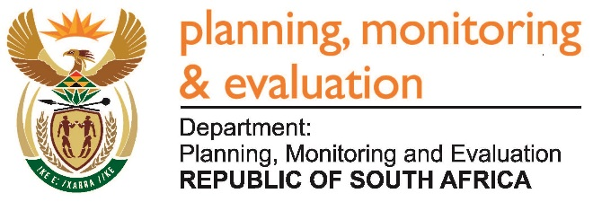 | 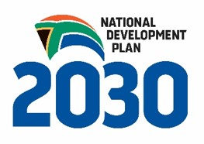
Private Bag X944, PRETORIA, 0001. Union Buildings East Wing, Government Avenue, PRETORIA
Tel: 012 312 0307. www.dpme.gov.za

____________________________________________________________________________________________
2423. Prof B Bozzoli (DA) to ask the Minister in the Presidency:

(a) What is the detailed role of each Minister appointed to the Ministerial Task Team on Higher Education, that was established by the President, Mr Jacob G Zuma, on 11 October 2016 to address the fees must fall crisis in tertiary institutions and (b) why was the Minister of Finance, Mr P J Gordhan, excluded from the specified task team? NW2805E

REPLY:

All members of the Ministerial Task Team on Higher Education were appointed by the President of the Republic to support the Minister of Higher Education and Training to normalise the situation at Higher Education institutions across the country. The Minister of Finance is one of the Ministers serving on this task team.

