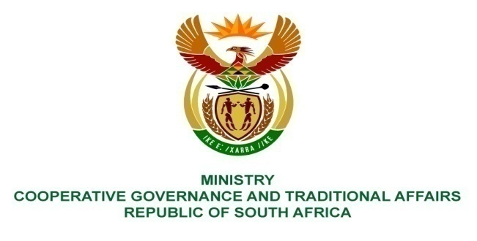
________________________________________________________________________________________

FOR WRITTEN REPLY
NATIONAL ASSEMBLY
PARLIAMENTARY QUESTION NO 2421

Mr D Bergman (DA) to ask the Minister of Cooperative Governance and Traditional Affairs:
Whether, with reference to the reply to question 4251 on 21 December 2015, the Ekurhuleni Metropolitan Municipality has provided the requested information; if not, by what date will they provide the requested information; if so, what are the relevant details of the information?

REPLY
- According to the answer provided to PQ 4251 on 21 December 2015, there is no information that was requested from Ekurhuleni over and above the information provided in the reply. For ease of reference, we hereby attach the 21 December 2015 reply.

