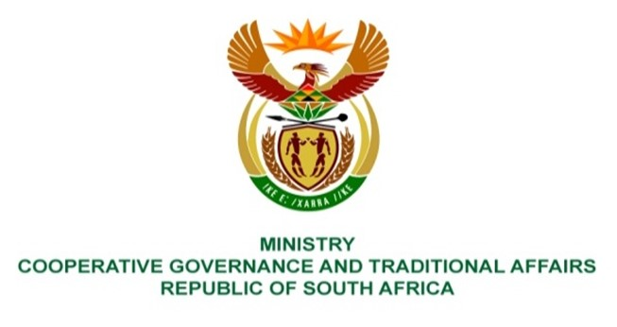

NATIONAL ASSEMBLY
QUESTION FOR WRITTEN

QUESTION NUMBER 2420
DATE OF PUBLICATION: 17 JUNE 2022

QUESTION:

2420. Mr K Ceza (EFF) to ask the Minister of Cooperative Governance and Traditional Affairs:
Whether she will issue a statement on the improvement of the (a) 89 unqualified municipal audits, (b) 66 qualified, (c) 6 adverse audits and (d) 12 disclaimers; if not, what is the position in this regard; if so, what are the relevant details? NW2846E
REPLY:

Subsequent to the release of the 2020/21 Local Government Audit Outcomes by the Auditor General of South Africa, we issued a media release on 15 June 2022. We noted the improvements in the number of municipalities with unqualified audit outcomes. In addition we outlined the department’s position and interventions in place to assist under-performing municipalities.
The media release is attached herewith as annexure A.

