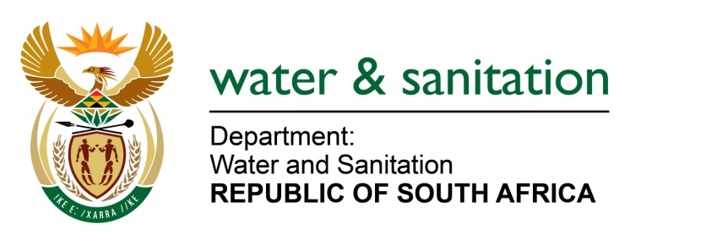

NATIONAL ASSEMBLY

FOR WRITTEN REPLY

QUESTION NO 2420

DATE OF PUBLICATION IN INTERNAL QUESTION PAPER: 26 JUNE 2015
(INTERNAL QUESTION PAPER NO. 23)

2420. Ms Z B N Balindlela (DA) to ask the Minister of Water and Sanitation:
What amount did (a) her department and (b) each entity reporting to her spend on advertising in (i) Sowetan and (ii) Daily Sun in the (aa) 2012-13, (bb) 2013-14 and (cc) 2014-15 financial years? NW2786E
---00O00---
REPLY:
Requesting the Honourable Member to refer to the response in NA 1128 published on 26 March 2015.
---00O00---

