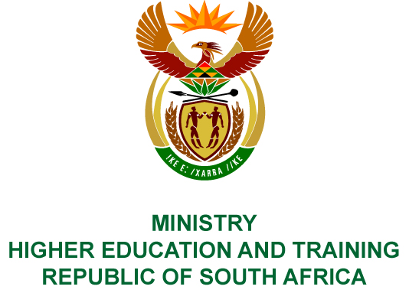
Private Bag X893, Pretoria, 0001, Tel (012) 312 5555, Fax (012) 323 5618
Private Bag X9192, Cape Town, 8000, Tel (021) 469 5150, Fax: (021) 465 7956
Memorandum from the Parliamentary Office
NATIONAL ASSEMBLY
FOR WRITTEN REPLY
QUESTION 2419
DATE OF PUBLICATION OF INTERNAL QUESTION PAPER: 24/08/2018
(INTERNAL QUESTION PAPER NO 26 OF 2018)
Ms H S Boshoff (DA) to ask the Minister of Higher Education and Training:
- What programmes for the Continuous Professional Training and Development of teachers at special needs schools are (i) currently being implemented and (ii) planned for future academic years and (b) what number of teachers are trained or will be trained in each programme?
NW2667E
REPLY:
- The development of inclusive education competence begins in initial teacher education programmes, and deeper specialisation is developed through continuing professional development programmes.
Universities offer initial teacher education and continuing professional development qualification programmes for teachers based on the policy requirements stipulated in the Policy on Minimum Requirements for Teacher Education Qualifications (PMRTEQ) (Department of Higher Education and Training 2011, revised in 2015).
The PMRTEQ makes it possible for universities to offer the following initial teacher education programmes:
- Bachelor of Education (BEd) (480 credits, NQF level 7); and
- Postgraduate Certificate in Education (PGCE) (120 credits, NQF Level 7).
The PMRTEQ requires that all BEd and PGCE graduates “must be knowledgeable about inclusive education and skilled in identifying and addressing barriers to learning, as well as in curriculum differentiation to address the needs of individual learners within a grade.”
(PMRTEQ, page 25 and 29)
The PMRTEQ specifies 11 basic competencies for beginner teachers. One of the competencies requires that “Newly qualified teachers must understand diversity in the South African context in order to teach in a manner that includes all learners. They must also be able to identify learning or social problems and work in partnership with social providers to address these.” (PMRTEQ, page 62)
To support the implementation of these policy directives, the Department is implementing the Teacher Education for Inclusive Teaching (TEfIT) Project. This project involves the collaborative development of knowledge and practice standards for inclusive teaching and supporting curriculum frameworks, courses and course materials that universities can use for the development of new and existing teachers’ inclusive teaching competence. The goal is that all new teachers graduating from initial teacher education programmes are able to address inclusive education competently in their practice.
A further component of the TEfIT Project involves support for three universities to develop as centres of specialisation for special needs education in three areas. The University of Pretoria is being supported to develop as a centre of specialisation for Visual Impairment Studies, the University of the Witwatersrand for Deaf Studies, and the University of Johannesburg for Neurological-Developmental Learning Needs. These centres will have the function of training specialist teachers who work/will work in special schools, special schools resource centres and full-service schools, and of leading research in these areas to inform policy and practice.
The three universities are developing programmes aligned with the PMRTEQ and Higher Education Qualifications Sub-Framework.
Table 1: Continuous Professional Development programmes under development by the three universities
University | Programmes under development | Target date for offering of programmes
University of Pretoria | Advanced Certificate: Inclusive Education (Barriers to Learning: Learning Difficulties) | 2020
 | Bachelor of Education (Honours):  (Special Needs and Inclusive Education) | 2020
 | Advanced Diploma in Education: Visual Impairment Studies | 2020
University of  the Witwatersrand | Post Graduate Diploma in Deaf Education (South African Sign Language as a language specialisation ) | 2020
 | Bachelor of Education Honours  (Deaf Education) | 2020
University of Johannesburg | Advanced Diploma in Education: Remedial Education | 2020
 | Postgraduate Diploma in Education (Inclusive Education) | 2020

Other universities are also active in this area. The latest audited 2016 data received from universities indicates the following Advanced Certificate in Education (ACE) programme offerings.
Table 2: Headcount Enrolments (HC), Full-time Equivalent Enrolments (FTE) and Graduates (Grads) in active inclusive education/special needs education in 2016.
University and ACE Specialisation |  | HC | FTE | Grads
Nelson Mandela University | Education: SNE: Remedial | 3 | 1 | 3
North West University | Learner Support | 209 | 68 | 97
University of South Africa | Inclusive Education | 41 | 15 | 28
University of Pretoria | Special Needs Education | 71 | 41 | 50
The number and range of ACE programme offerings were much higher a few years ago, and many teachers completed their ACE qualifications with an inclusive education/remedial education/special needs education focus. The number of graduates are now declining because the ACE is not aligned to the HEQSF and being phased out. Universities will replace the ACE specialisations with Advanced Diplomas in Education and Postgraduate Diplomas in Education.
The scale at which the new Advanced Diplomas and Postgraduate Diplomas will be offered will be dependent on the extent to which the Department of Basic Education signals a need for them and teachers are supported to enrol for the specialist programmes.
It is not possible for the Department of Higher Education and Training to predict future numbers of teachers who will undertake these specialist programmes. This is dependent on the extent to which teachers choose to do these courses, or are specifically supported by the Department of Basic Education and provincial education departments to register for these programmes.

