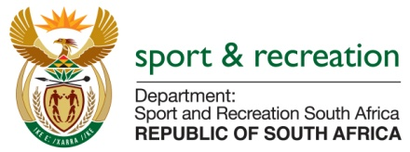

PARLIAMENTARY QUESTION FOR THE MINISTER

QUESTION
2419. Mr M S Malatsi (DA) to ask the Minister of Sport and Recreation:

(1) (a) What was the total value in rand of Old Mutual's sponsorship for Athletics South Africa's (ASA) licence numbers for races in the past three financial years, (b) for what period was each of the sponsorships allocated and (c) what is the name of each board member and/or official of ASA that secured the sponsorships;

(2) whether the specified board members and/or officials of ASA were awarded (a) commissions and/or (b) any other incentives for securing the sponsorships; if not, what is the position in this regard; if so, (i) what amount in commission and/or other incentives did each of the board members and/or officials receive in each of the specified financial years and (ii) what are the further relevant details in this regard? NW2801E
REPLY

- (a) What was the total value in rand of Old Mutual's sponsorship for Athletics South Africa's (ASA) licence numbers for races in the past three financial years,

R5,000,000.00 – as from 2016

b) for what period was each of the sponsorships allocated and

2016 and 2017

(c) what is the name of each board member and/or official of ASA that secured the sponsorships;

Mr Aleck Skhosana and James Moloi

(2) whether the specified board members and/or officials of ASA were awarded
(a) Commissions and/or

No commission were awarded

(b) any other incentives for securing the sponsorships; if not, what is the position in this regard; if so,

No other incentives to be awarded and no future prospects of incentives or commission to be awarded

- what amount in commission and/or other incentives did each of the board members and/or officials receive in each of the specified financial years and

None

- What are the further relevant details in this regard?

None

