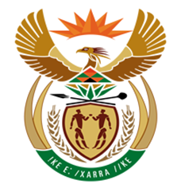

NATIONAL ASSEMBLY

QUESTION FOR WRITTEN REPLY
QUESTION NUMBER: 2415 [NW2663E]
DATE OF PUBLICATION: 18 August 20170
2415. Mr D J Maynier (DA) to ask the Minister of Finance:
(1) With reference to his reply to question 1381 on 3 July 2017, since what date has a certain person (name furnished) been on suspension from the SA Revenue Service (SARS);
(2) whether the specified person was escorted out of the SARS premises by security officials; if not, why not; if so, why? NW2663E
REPLY:

- Mr Jonas Makwakwa was officially suspended on 15 September 2016.

- His suspension was effected in accordance with the provisions and relevant procedures of the SARS suspension policy.

