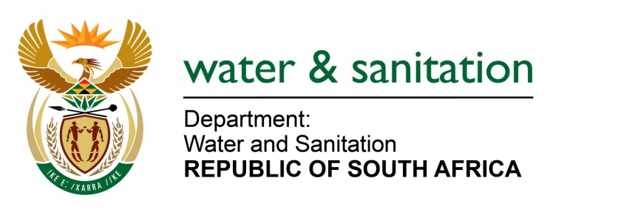

NATIONAL ASSEMBLY

FOR WRITTEN REPLY

QUESTION NO 2412

DATE OF PUBLICATION IN INTERNAL QUESTION PAPER:
(INTERNAL QUESTION PAPER NO. 23) 09 JUNE 2023
2412. Mrs M R Mohlala (EFF) to ask the Minister of Water and Sanitation:
What (a) progress has been made in the realignment of water boards in the Republic, (b) are the key objectives, challenges faced and measures taken to ensure the improved water management, service delivery and growth in the water sector, (c) specific areas and/or regions in the Republic have been most affected by the realignment process and (d) timeline and milestones have been set for the completion?
NW2753E
---00O00---

MINISTER OF WATER AND SANITATION

- Progress made towards the realignment of water boards is indicated in Annexure A below.

- The reconfiguration of the Water Boards was intended to improve financial sustainability, extend services to areas that are not currently serviced and address institutional confusion caused by having multiple Water Boards serving the same area.

The Minister initiated the reconfiguration of Water Boards to:
- Strengthen the capacity and capability of the entities in Provinces (leveraging on existing technical skills)
- Improve and enhance institutional efficiencies and rationalise the number of institutions in the water sector to ensure economies of scale,
- Maintain financial viability and enhance the ability to raise capital from the market for infrastructure projects.
- The Department has reviewed the Water Boards in terms of financial sustainability, servicing areas that are not currently serviced and institutional confusion caused by having multiple Water Boards serving the same area.

The Minister initiated the reconfiguration of Water Boards to:
- Strengthen the capacity and capability of the entities in Provinces (leveraging on existing technical skills)
- Improve and enhance institutional efficiencies and rationalise the number of institutions in the water sector to ensure economies of scale,
- Maintain financial viability and enhance the ability to raise capital from the market for infrastructure projects.

- The provinces in the Republic have been most affected by the realignment process are indicated in Annexure A.

- Timelines that have been set for the completion of the reconfiguration processes are indicated in Annexure A.

---00O00---

ANNEXURE A

(a) Progress made with realignment of Water Boards | (c) Affected areas and/or regions | (d) Timeline and milestones
Disestablishment of Sedibeng Water | Free State, North West and Northern Cape | February 2022 to 1 August 2022
Sedibeng Water was disestablished in July 2022. The assets and liabilities in the North West were transferred to Magalies Water and the Free State and Northern Cape assets and liabilities were transferred to Bloem Water as of 1 August 2022.
Sedibeng Water was delisted as a schedule 3B of the Public Finance Management Act, 1999 (Act No 1 of 1999) (PFMA). |  | 28 Mach 2023
Reconfiguration of Bloem Water | Free State and Northern Cape | 1 August 2022 to July 2023
Bloem Water services the entire Free State and Northern Cape and has taken over the staff, assets and liabilities from Sedibeng with effect from 01 Aug 2022.
The Gazette Notice for comments to be published for thirty (30) days outlining the intention to change the name of Bloem Water to Vaal Central Water Board was published
Final Gazette to change the name of Bloem Water to Vaal Central Water Board to be published
Reconfiguration of Umgeni & Mhlathuze | Kwa-Zulu Natal | July 2022 to 01 July 2023
The Minister consulted with the KwaZulu-Natal Provincial Government in terms of Section 28 of the Water Services Act, 1997 (Act No. 108 of 1997).
Minister published the Gazette Notice for thirty (30) days to change the name Umgeni Water to uMngeni-uThukela Water with effect from 01 July 2023. |  | 19 June 2023
Minister published a final gazette notice extending the boundary of Umgeni Water to include Mhlathuze Water to form a single Water Board in the KwaZulu-Natal Province, disestablish Mhlathuze Water, the transfer of staff, assets and liabilities to uMngeni-uThukela Water with effect from 01 July 2023 |  | 19 June 2023
Advert calling for nominations for a new Board Members for the single Water Board in KwaZulu-Natal (uMngeni-uThukela Water) published |  | 25 June 2023
Rand Water boundary to be extended to cover Mpumalanga and Gauteng Province | Gauteng and Mpumalanga | October 2022 to March 2024
The Minister published a Gazette Notice on 28 November 2022 in terms of Section 28(1) of the WSA for sixty (60) days outlining his intentions to extend the service area of Rand Water to Provide Bulk Water Services to the entire Mpumalanga Province.
Final due diligence is due on October 2023
Lepelle boundary will be extended to cover the entire Limpopo Province. | Limpopo | October 2022 to January 2024
High level desktop due diligence analysis is due by end of September 2023
Gazette notice to be published on the extension to cover Limpopo Province.
Transfer of Rand Water’s asset in Rustenburg from Rand Water to Magalies Water and transfer of Magalies Water assets to Rand Water | Gauteng and North West | July 2022 to December 2023
Final due Diligence is due on September 2023
Amatola Water Board will be extended to cover the entire Eastern Cape Province. | Eastern Cape | October 2022 to December 2023
The Minister published a Gazette Notice on 14 November 2022 in terms of Section 28(1) of the WSA for sixty (60) days outlining intentions to extend the service area of Amatola Water to cover the entire Eastern Cape Province.
High level desktop due diligence analysis is due by end of September 2023
Overberg Water Board will be extended to cover the entire Western Cape Province | Western Cape | November 2022 to December 2023
The Minister published a Gazette Notice on 3 November 2022 in terms of Section 28(1) of the WSA for sixty (60) days outlining intentions to extend the service area of Overberg Water to cover the entire Western Cape Province.
High level desktop due diligence analysis is due by end of September 2023

