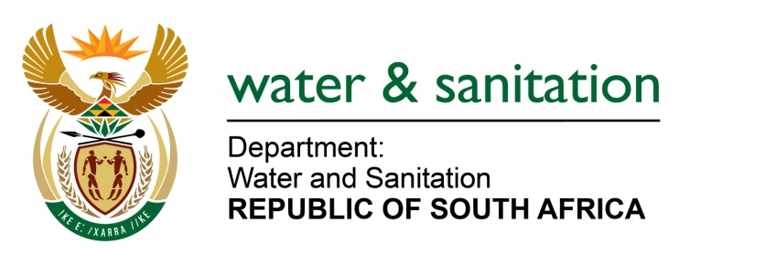

NATIONAL ASSEMBLY

FOR WRITTEN REPLY

QUESTION NO 241

DATE OF PUBLICATION IN INTERNAL QUESTION PAPER:
(INTERNAL QUESTION PAPER NO. 2) 17 FEBRUARY 2023

241. Mr D W Bryant (DA) to ask the Minister of Water and Sanitation:
(1) With reference to Parts 9 and 10 of the National Water Act, Act 36 of 1998, which deals with licensed sewage package plants, (a) what is the total number of licensed plants in (i) each province and (ii) total in the Republic and (b) of those licensed plants, what percentage were (i) inspected and (ii) audited correctly in each year since 2009 until the latest date of which information is available in 2023;
(2) with reference to the specified Act which deals with unlicensed sewage package plants, upon conducting inspections and audits, (a) how does his department assess what environmental damage has resulted from non-compliance and (b) what action has been taken by his department where plants were found to be non-compliant with their licensing conditions? NW245E
---00O00---

MINISTER OF WATER AND SANITATION
- Part 9 of the National Water Act, Act 36 of 1998 (NWA) deals the review and renewal of licenses, and the amendment and substitution of conditions of licenses. Part 10 deals with contravention of or failure to comply with authorisations. None of these parts of legislation deal directly with sewage package plants.

- (i) The details for each province are summarised in the table below.

(ii) The total number of authorized package plants (wastewater treatment and drinking water treatment) is 43. This number refers to facilities with a capacity of 2 mega litres per day and are authorised in terms of the NWA through general authorizations (GA) and water use licences (WUL).
PROVINCE |  | No. of AUTHORIZED PACKAGE PLANTS(≤2M/L) | AUDITS CONDUCTED
 |  |  | 2019 | 2020 | 2021 | 2022 | 2023
1 | EASTERN CAPE | 13 | - | - |  | 2 | 11
2 | WESTERN CAPE | 6 | - | - | - | 5 | -
3 | NORTHERN CAPE | 4 | - | - |  | 3 | -
4 | FREE STATE | 0 | - | - | - | - | -
5 | KWAZULU - NATAL | 5 | - | - | - | - | -
6 | MPUMALANGA | 10 | - | - | - | - | -
7 | LIMPOPO | 1 | - | - | - | - | 1
8 | NORTH WEST | 2 | - | - | - | - | -
9 | GAUTENG | 2 | - | - | - | - | 1
TOTALS |  | 43 | 0 | 0 | 0 | 10 | 14

(i-ii) No inspection conducted. Audits were conducted on 56% of the package plants in the period 2009 until 2023. More audits were conducted in the years 2022 and 2023 due to the Blue Drop and Green Drop Programme

- (a) Authorisations issued to the package plants have conditions prescribing how much waste and waste concentrations can be released to the environment. The teams that conduct audits of package plants are trained Environmental Management Inspectors (EMIs) with capabilities of determining whether the conditions have been breached or not. In cases of non-compliance resulting in pollution of the environment, such pollution can be quantified in terms on its impact to the environment.
(b) In terms of the NWA, any water use license holder who fails to comply with license conditions commits a criminal offense in terms of Section 151(1)(c) in which the offender becomes liable to a fine or imprisonment or both. Therefore, if a water user has failed to comply with any of the license conditions, DWS first exercises administrative enforcement in the form of Notices and Directives which affords the water user an opportunity to rectify any non-compliances. In cases of further failure to comply, the DWS proceeds with either or both criminal and civil enforcement actions.

---00O00---

