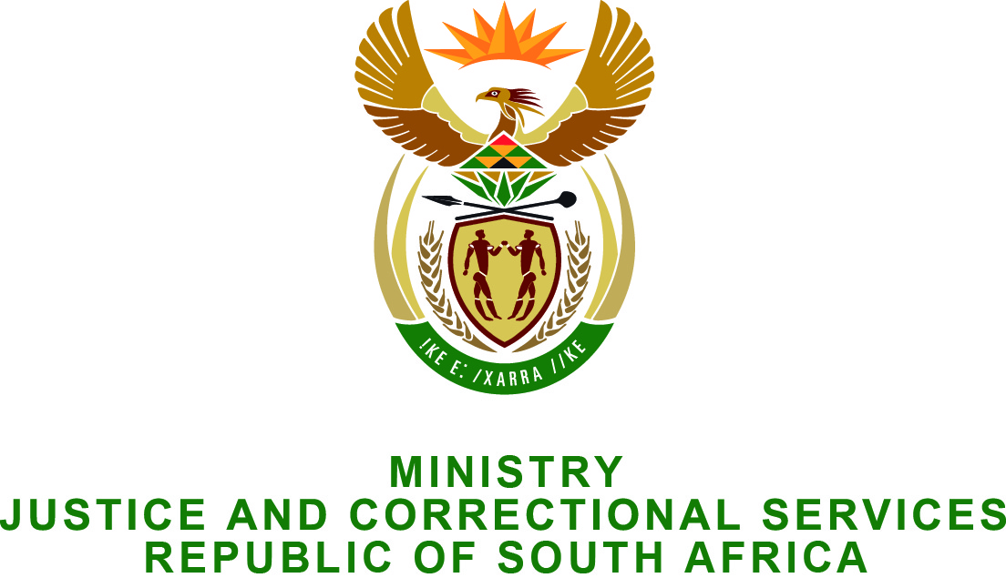

NATIONAL ASSEMBLY
QUESTION FOR WRITTEN REPLY
PARLIAMENTARY QUESTION NO.: 2409
DATE OF QUESTION: 26 JUNE 2015
DATE OF REPLY: 10 JULY 2015

Adv G Breytenbach (DA) to ask the Minister of Justice and Correctional Services:
What amount did (a) his department and (b) each entity reporting to him spend on advertising in (i) Sowetan and (ii) Daily Sun in the (aa) 2012-13, (bb) 2013-14 and (cc) 2014-15 financial years? NW2775E

REPLY:
- The Department of Justice and Constitutional Development spent the following amounts on advertising:
Publication | (aa) 2012/2013 | (bb) 2013/2014 | (cc) 2014/2015
- Sowetan | N.A. | R1,899,151.22 | R2,207,842.37
- Daily Sun | N.A. | R2,184,923.24 | R1,894,286.46

- (i)Legal Aid SA:
Publication | (aa) 2012/2013 | (bb) 2013/2014 | (cc) 2014/2015
- Sowetan | R60,374.40 | R154,967.04 | R90,944.64
- Daily Sun | R112,039.20 | R186,732.00 | R149,385.60
(iii) National Prosecuting Authority:
Publication | (aa) 2012/2013 | (bb) 2013/2014 | (cc) 2014/2015
- Sowetan | R28,892.16 | R18,374.76 | R275,193.26
- Daily Sun | N. A. | N.A. | R59,635.68

(ii) Special Investigation Unit:
The SIU has reported that they have not spent on advertising in the Sowetan and Daily Sun newspapers in the period in question.

Department of Correctional Services

The details pertaining to amount spent on advertising are as follows:

(i) The Sowetan

(aa) 2012-13 financial year : None
(bb) 2013-14 financial year : None
(cc) 2014-15 financial year : R59 540.83

(ii) The Daily Sun

(aa) 2012-13 financial year : None
(bb) 2013-14 financial year : None
(cc) 2014-15 financial year: None

Office of the Chief justice and judicial administration

The Office of the Chief Justice did not place any advertisements in the (i) Sowetan and (ii) Daily Sun newspapers in the (aa) 2012-13, (bb) 2013-14 and (cc) 2014-15 financial years, consequently no monies were spent towards advertising.

