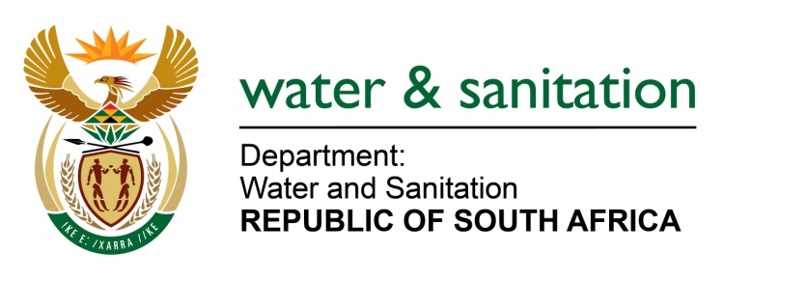

NATIONAL ASSEMBLY

FOR WRITTEN REPLY

QUESTION NO 2407

DATE OF PUBLICATION IN INTERNAL QUESTION PAPER: 17 JUNE 2022
(INTERNAL QUESTION PAPER NO. 24)

2407. Mrs C Phillips (DA) to ask the Minister of Water and Sanitation:
(a) What (i) total number of use licenses applications for chrome wash plants were rejected since 2016, (ii) are the names of the (aa) individuals and (bb) companies who applied for the licenses and (b) where were the wash plants going to be located?
NW2832E

---00O00---
MINISTER OF WATER AND SANITATION

- Based on our database there is one (1) water use licence application for chrome wash plant that was withdrawn by the applicant since 2016.

- The details are indicated below:

No | Name of Applicant | Property Details | Region | Date of withdrawal
1 | Glencore Operations South Africa (PTY) LTD Glencore Chrome Plant | Portion 3 of Land Parcel 462 of the Major Region JQ | NW | 2021/10/25

---00O00---

