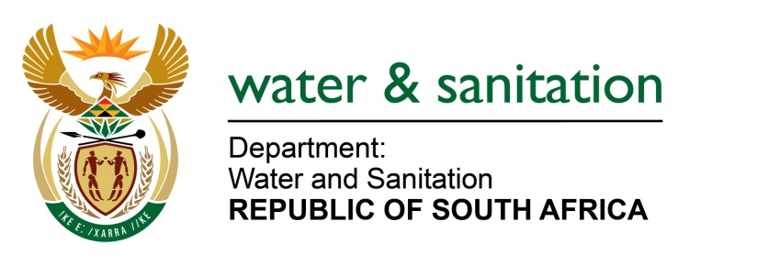

NATIONAL ASSEMBLY

FOR WRITTEN REPLY

QUESTION NO 2406

DATE OF PUBLICATION IN INTERNAL QUESTION PAPER: 17 JUNE 2022
(INTERNAL QUESTION PAPER NO. 24)

2406. Mrs C Phillips (DA) to ask the Minister of Water and Sanitation:
What (a)(i) total number of water use licenses applications for chrome wash plants in the Bojanala Platinum District have been received since 2016 and (ii) have not yet been processed, (b) are the names of the (i) individuals and (ii) companies who applied for the licenses and (c) is the identified location of the wash plants in each case?
NW2831E
---00O00---

MINISTER OF WATER AND SANITATION

- Since 2016 the Department received four (4) water use licenses applications for chrome wash plants in the Bojanala Platinum District. Currently there are no applications that are yet to be finalised for chrome wash plants in the Bojanala Platinum District.

- Please refer to the table below:

No | Name of Applicant | Property Details | Region | Application Date
1 | Glencore Operations South Africa(PTY)LTD Glencore Chrome Plant | Portion 3 of Land Parcel 462 of the Major Region JQ | NW | 2018/09/03
2 | Rustenburg Platinum Mine: Amandelbult Fine Chrome Recovery Plant | Land Parcel 383 of the Major Region KQ | NW | 2019/04/05
3 | Kumene Technologies | Rustenburg on Farm and Townlands of Rustenburg 272 JQ | NW | 2016/06/01
4 | Anglo American Platinum (Pty) Ltd: Amandelbul Complex Fine Chrome Complex Recover Plant | Schilpadnest 385 KQ | NW | 2019-04-05

---00O00---

