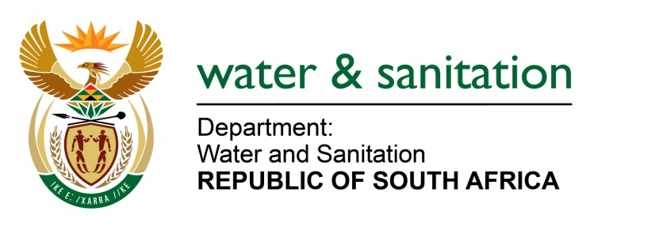

NATIONAL ASSEMBLY

FOR WRITTEN REPLY

QUESTION NO 2405

DATE OF PUBLICATION IN INTERNAL QUESTION PAPER: 17 JUNE 2022
(INTERNAL QUESTION PAPER NO. 24)

2405. Mrs C Phillips (DA) to ask the Minister of Water and Sanitation:
What (a) number of water use licenses have been issued to existing chrome wash plants in the Bojanala Platinum District since 1 January 2011, (b) are the names of the (i) individuals and (ii) companies who hold the licenses and (c) is the location of each of the wash plants?
NW2830E

---00O00---

MINISTER OF WATER AND SANITATION

- There are 7 Water Use Licences issued to existing chrome wash plants in the Bojanala Platinum District since 1 January 2011.

- The list below indicates the details of the applicants.

No | Name of Applicant | Property Details | Region | Date of Issuance
1 | Rustenburg Platinum Mine: Amandelbult Fine Chrome Recovery Plant | Land Parcel 383 of the Major Region KQ | NW | 2022/03/26
2 | Elgagen (Pty) Ltd–Zandfontein Chrome Wash Plant | Portion of portion 181 (a Portion of Portion 2) of the Farm Zandfontetn 447 JQ | NW | 2018/05/16
3 | Kumene Technologies | Rustenburg on Farm and Townlands of Rustenburg 272 JQ | NW | 2020/12/08
4 | Xstrata Alloys Wonderkop plant | Brakspruit 229 JQ, Spruitfontein 341 JQ and Hoedspruit 298 JQ | NW | 2011-02-12
5 | Evraz Vametco Alloys (Pty) Ltd | Krokodilkraal 426 JQ | NW | 2017-05-31
6 | Eagle Granite (Pty) Ltd | Portion 1176, 1177, 1178, 1179, 1180, 1181, 1182, 1183 and the remaining extent of the Farm Hartebeestpoort B410JQ | NW | 2015-04-30
7 | Anglo American Platinum (Pty) Ltd: Amandelbul Complex Fine Chrome Complex Recover Plant | Schilpadnest 385 KQ | NW | 2022-03-26

---00O00---

