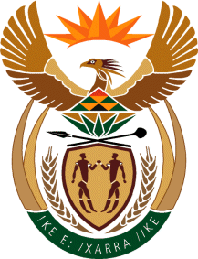
MINISTRY
SPORT AND RECREATION
REPUBLIC OF SOUTH AFRICA

Department of Sport and Recreation l Private Bag X896 l PRETORIA l 0001 l Regent Place l 66 Queen Street l Pretoria l 0001 l +27 (0)12 304 5053 l Fax: +27 (0)12 323 8426
Private Bag X9149 l Cape Town l 8000 l 2nd Floor Parliament Building l 120 Plain Street l CAPE TOWN l Tel: +27 21 469 5705 l Fax: +27 21 465 4402
www.srsa.gov.za
_____________________________________________________________________

NATIONAL ASSEMBLY

WRITTEN REPLY

QUESTION PAPER: No. 28 of 18 AUGUST 2017

DATE OF REPLY: 20 SEPTEMBER 2017

2400. Mr T W Mhlongo (DA) asked the Minister of Sport and Recreation:

Has Boxing South Africa conducted an investigation into the death of Herbert Nkabiti, a boxer; if not, why not; if so, will he furnish Mr T W Mhlongo with a copy of the investigation report? NW2648E
______________________________________________________________________
The Minister of Sport and Recreation
REPLY:

The investigation into the death of Mr Herbert Nkabiti is underway and has not yet been completed. The investigation has been commissioned by the board of Boxing South Africa. Once the investigation is complete and the report is submitted to the Department of Sport and Recreation South Africa, the Minister will apply his mind as to the next course of action.

