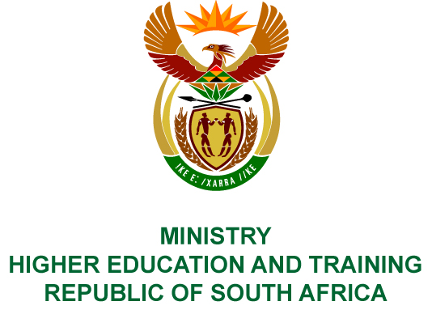
Private Bag X893, Pretoria, 0001, Tel (012) 312 5555, Fax (012) 323 5618
Private Bag X9192, Cape Town, 8000, Tel (021) 469 5150, Fax: (021) 465 7956
Memorandum from the Parliamentary Office
NATIONAL ASSEMBLY
FOR WRITTEN REPLY
QUESTION 24
DATE OF PUBLICATION OF INTERNAL QUESTION PAPER: 08/02/2018

(INTERNAL QUESTION PAPER NO 1 OF 2018)
Prof B Bozzoli (DA) to ask the Minister of Higher Education and Training:
With reference to the reply to question 2463 on 5 September 2017, what steps has (a) the National Student Financial Aid Scheme (NSFAS) and (b) her department taken to encourage students to pay off their debt owed to NSFAS?

NW28E

REPLY:
- The National Student Financial Aid Scheme (NSFAS) has put in place the following collection processes during the 2015/16 financial year to increase recoveries:
- Appointment of External Debt Collectors (EDC) to contact debtors who are working in the public and private sector. NSFAS is also working with private companies and associations, e.g. Association for Savings and Investment South Africa (ASISA) and South African Insurance Association (SAIA) to allow for payroll deductions from their employees as well as certain government departments;
- NSFAS plans to do soft collections via the contact centre by calling and emailing debtors on a small to medium scale before the debtors are handed over to EDC for collections from the 2018/19 financial year onwards;
- NSFAS sends out quarterly statements to enable debtors to make payment arrangements via debit order directly to the Scheme;
- NSFAS has embarked on an extensive recoveries communication campaign to create awareness and encourage previous beneficiaries to pay, utilising different mediums of communication throughout the country, i.e. television, radio, print media as well as social media platforms;
- NSFAS receives assistance from the National Treasury to secure payroll deductions from government departments. It received secondments from Standard Bank and First National Bank. The First National Bank secondment assists NSFAS with implementation of the recoveries strategy. The Standard Bank secondment assists with all reporting requirements for recoveries, building a data warehouse, dashboard and reporting on the performance statistics of EDC; and
- The entity is also getting assistance from SARS on a quarterly basis.
- The recoveries mandate remains the responsibility of NSFAS. The Department provides oversight and monitoring to ensure that NSFAS fulfils its obligations in this regard.

COMPILER DETAILS
NAME AND SURNAME: MR MORGAN NHIWATIWA
CONTACT: 021 763 3200 Ext 289
RECOMMENDATION
It is recommended that the Minister signs Parliamentary Question 24.

MR GF QONDE
DIRECTOR–GENERAL: HIGHER EDUCATION AND TRAINING
DATE:

PARLIAMENTARY QUESTION 24 IS APPROVED / NOT APPROVED / AMENDED.
COMMENTS

PROF HB MKHIZE, MP
MINISTER OF HIGHER EDUCATION AND TRAINING
DATE:

