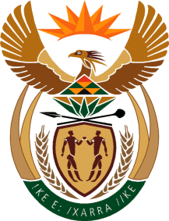

MINISTRY OF TOURISM
REPUBLIC OF SOUTH AFRICA

Private Bag X424, Pretoria, 0001, South Africa. Tel. (+27 12) 444 6780, Fax (+27 12) 444 7027
Private Bag X9154, Cape Town, 8000, South Africa. Tel. (+27 21) 469 5800, Fax: (+27 21) 465 3216

NATIONAL ASSEMBLY:

QUESTION FOR WRITTEN REPLY:
Question Number: 2396
Date of Publication: 16 October2020
NA IQP Number: 38
Date of reply: 05 November 2020

Mr K P Sithole (IFP) to ask the Minister of Tourism:
Whether, given that despite the eased regulations the tourism industry remains the hardest hit sector due to the nationwide lockdown to curb the spread of Covid-19, her department has a plan to implement adjustments in pricing in order to promote local tourism as has become a global trend? NW2971E

REPLY:
The setting of prices falls within the ambit of the private sector. South African Tourism does engage the sector to consider special offers as part of the promotion activities they conduct i.e. Sho’t Left programme. The Minister of Tourism has commenced with a consultation process with the sector on the concept of dual pricing.

