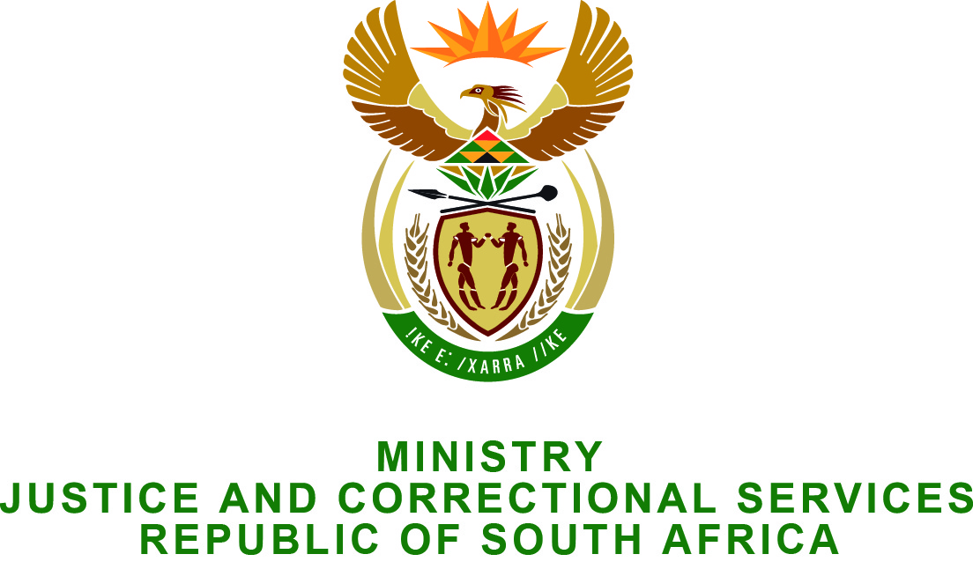

NATIONAL ASSEMBLY
QUESTION FOR WRITTEN REPLY
PARLIAMENTARY QUESTION NO.: 2394
DATE OF QUESTION: 19 JUNE 2015
DATE OF REPLY: 03 JULY 2015

Mr S Mokgalapa (DA) to ask the Minister of Justice and Correctional Services:
- How many witnesses have (a) been attacked or (b) died while under witness protection (i) in the (aa) 2009/10; (bb) 2010/11, (cc) 2011/12, (dd)2012/13, (ee) 2013/14 and (ff) 2014/15 financial years and (ii) from 1 April 2015 up to the latest date for which information is available;
- How many of the specified incidences resulted in investigations (a) which are still in progress and (b) which have been completed in respect of each specified financial year or time period;
- How many investigated cases were found to involve breaches in security committed by members of SA Police Service in respect of each specified financial year or time period? NW2759E

REPLY:
The Office for Witness Protection (OWP) is an independent covert office and is a sub-programme of the Department of Justice and Constitutional Development. Its mandate is derived from the Witness Protection Act 112 of 1998.
Witness protection, in terms of the Witness Protection Act, is not a police or prosecution function; therefore the honourable Minister of Police is not the correct minister to respond to the said questions (as in PQ 2395).
Regarding the question posed to the Minister of Justice and Correctional Services, I wish to inform the Honorable member as follows:
- For the financial periods 2001/02 up to 2014/15 and current financial year up to date, no witness or their related person/s were attacked, threatened or killed while in the programme.
- Falls away.
- Falls away.

