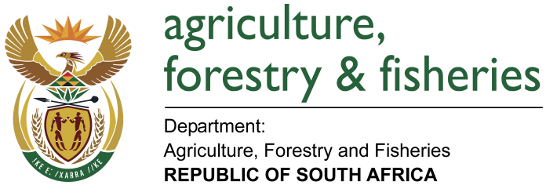
NATIONAL ASSEMBLY

WRITTEN REPLY

QUESTION 2392 / NW 2637E

MINISTER OF AGRICULTURE, FORESTRY AND FISHERIES:
Mr N Singh (IFP) to ask the Minister of Agriculture, Forestry and Fisheries:

QUESTION:
What legislative or regulatory amendments is his department considering to implement in order to ensure that the transportation of live farm animals from the country to Mauritius is conducted in a manner that is consistent with best humane live farm animal transport practices and the welfare of animals during transit from farms, aboard sea vessels and at the receiving ports of destination? NW2637E

REPLY:

The department has started engaging in the drafting of a new Animal Welfare Act since the current legislation in South Africa (the Animal Protection Act, 1962 and the Performing Animals Protection Act, 1935) which are the principal Acts governing the protection of animals are outdated and do not comprehensively address some animal welfare issues and are also not compatible with international standards.

The draft Animal Welfare Bill is still to undergo consultation and other legislation development processes and once promulgated its regulations and schemes will be implemented as per the objectives of the Act. The transporting of live animals will form part of the identified areas that need to be well encompassed in the legislation review process.

Until the time the new Act is promulgated, the Department of Agriculture, Forestry and Fisheries (DAFF) has committed to draft guidelines on key identified areas, and these include the transportation of animals by sea. These guidelines will be based on the OIE minimum standards which include key aspects that seek to address the exporter competency as well as the vessel requirements that transport the animals.

