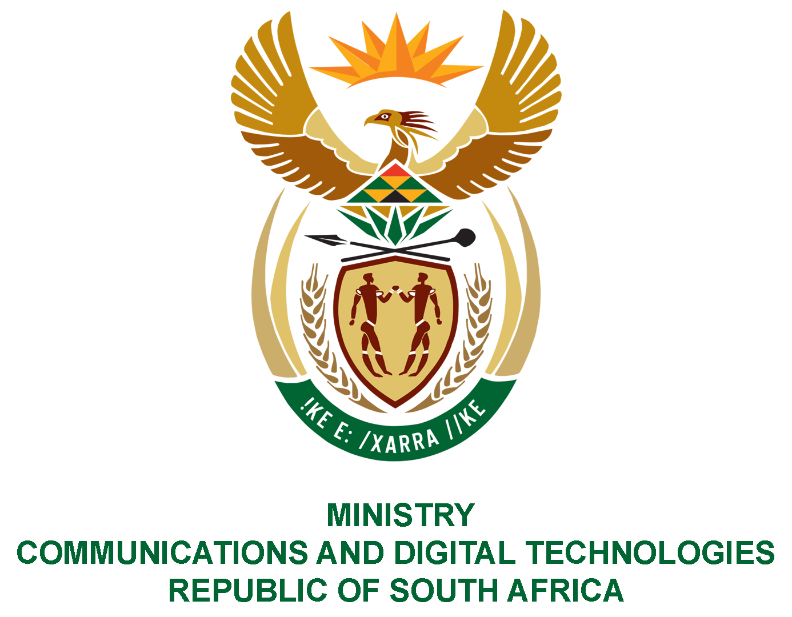

PARLIAMENT OF THE REPUBLIC OF SOUTH AFRICA
NATIONAL ASSEMBLY
WRITTEN REPLY

QUESTION NO: 2385
DATE OF PUBLICATION: 20 JUNE 2022
QUESTION PAPER NO: 24

Ms Bodlani DA to ask the Minister of Communications and Digital Technologies:
Who are the directors of a certain company (Leratadima Marketing Solution) which is currently involved in litigation on various cases worth Millions Rands with the Universal Services and Access Agency of South Africa (USAASA)?

REPLY:

I have been advised by the USAASA as follows:

The company in question was liquidated in December 2018 and the appointed liquidators are Mr. R. K. Pollock N.O, Mr. R. F. Lutchman N.O. and Ms R Pieters N.O. The directors before liquidation were Mr. Itumeleng Mafoko and Ms. Mabuyi Memela.

