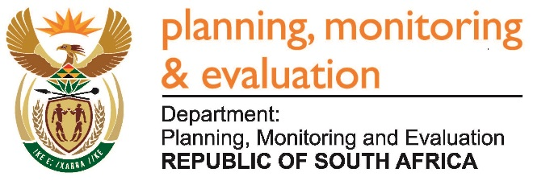
Private Bag X944, PRETORIA, 0001. Union Buildings East Wing, Government Avenue, PRETORIA
Tel: 012 312 0307. www.dpme.gov.za
2382. Ms A P van der Westhuizen (DA) to ask the Minister in the Presidency:

(1) With reference to the remuneration paid to the six senior managers of the National Youth Development Agency (NYDA) as listed in the specified entity’s 2015-16 annual report, (a) what position did each of the specified senior managers hold in the NYDA, (b) for how long did each of the senior managers receive remuneration and (c) what is the total amount that was paid out in remuneration for each of the senior managers in terms of (i) basic salaries and (ii) any benefits;

(2) whether any retrenched senior managers of the NYDA received severance packages in the 2015-16 financial year; if so, what is the total amount that was paid out in severance packages for each of the retrenched senior managers? NW2764E
REPLY:
In total the NYDA annual report refers to 8 senior management posts that were filled at beginning of the 2015 / 2016 financial year and 5 that were filled at the end of the financial year. The reduction is due to the organizational restructuring programme which saw the overall number of posts reduced.
The tables below indicate the number of senior management posts held before and after the restructuring and the basic salaries and additional benefits including the salary benefits received by the respective senior managers:

Posts prior to restructuring (1 April 2015 – 31 August 2015)
Post | Number of months received rem 2015 / 2016 FY | Short term benefits | Bonus | Expense allowance | Defined contribution plan | Severance benefit | Total
Chief Financial Officer | 5 | 431 000 | 95 000 | 21 000 | 28 000 | - | 575 000
Chief Information Officer | 5 | 454 000 | 177 000 | 3000 | 25 000 | 1 061 000 | 1 720 000
Executive Manager: Service Delivery Channel | 5 | 392 000 | 234 000 | 66 000 | 29 000 | 1 033 000 | 1 754 000
Executive Manager: National Youth Service and Skills Development | 5 | 331 000 | 243 000 | 18 000 | 78 000 | - | 670 000
Executive Manager: Corporate Services | 5 | 338 000 | - | 37 000 | 79 000 |  | 454 000
Executive Manager: Research and Policy | 7 | 661 000 | 95 000 | 2 000 | 31 000 | 1 108 000 | 1 897 000
Executive Manager: Communications | 5 | 477 000 | 200 000 | 14 000 | 29 000 | 823 000 | 1 543 000
Executive Manager: Corporate Partnerships and International Relations | 5 | 427 000 | 187 000 | 21 000 | 26 000 | 1 071 000 | 1 732 000
Total |  |  |  |  |  |  | 10 345 000

Posts after the restructuring (1 September 2015 – 31 March 2016)
 | Number of months received rem 2015 / 2016 FY | Short term benefits | Bonus | Expense allowance | Defined contribution plan | Severance benefit | Total
Chief Financial Officer | 7 | 603 000 |  | 30 000 | 39 000 | - | 672 000
Executive Director: Operations | 7 | 464 000 |  | 26 000 | 109 000 | - | 599 000
Executive Director: National Youth Service | 7 | 607 000 |  | 2 000 | 4 000 | - | 649 000
Executive Director: Corporate Services | 7 | 473 000 |  | 41 000 | 96 000 | - | 610 000
Executive Director: Corporate Strategy and Planning | 7 | 483 000 |  | 3 000 | 91 000 | - | 577 000
Total |  |  |  |  |  |  | 3 107 000

