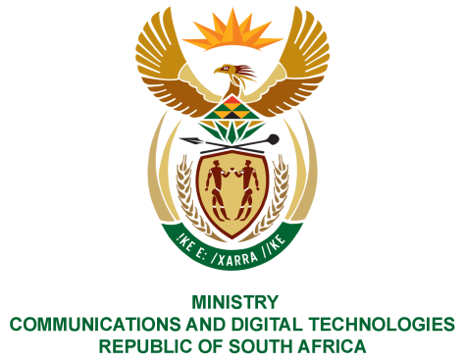
PARLIAMENT OF THE REPUBLIC OF SOUTH AFRICA
NATIONAL ASSEMBLY
WRITTEN REPLY

QUESTION NO: 2830
DATE OF PUBLICATION: 2 SEPTEMBER 2022
QUESTION PAPER NO: 29
Ms. Z Majozi (IFP) to ask the Minister of Communications and Digital Technologies:
(1) With reference to the Broadcasting Digital Migration, what number of households have applied for set-top boxes through the SA Post Office to date;
(2) Whether she has found that her department will meet its targets for the deadline of 30 September 2022; if not, why not; if so, what are the relevant details?
NW3427E
REPLY:
1. About 1, 5 million registrations have been recorded since the commencement of registrations in September 2015 to date.
2. A date of 30 September 2022 is gazetted and remains the deadline for citizens to make application for Government subsidised Set-top box. We have created sufficient awareness around the final registrations date, and the Minister does not intend issuing another gazette to extend the registration deadline.
Authorised for submission by

MS. NONKQUBELA JORDAN-DYANI
DIRECTOR-GENERAL (ACTING)
DATE:

Recommended/not recommended

__________________________
HON. PHILLY MAPULANE, MP
DEPUTY MINISTER OF COMMUNICATIONS AND DIGITAL TECHNOLOGIES
DATE:

Approved/ not approved

________________________________
HON. KHUMBUDZO NTSHAVHENI, MP
MINISTER OF COMMUNICATIONS AND DIGITAL TECHNOLOGIES
DATE:

