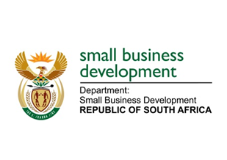
NATIONAL ASSEMBLY
QUESTION FOR WRITTEN REPLY
DUE IN PARLIAMENT: 1 JULY 2022

“2380. Mr H C C Krüger (DA) to ask the Minister of Small Business Development:
What total number of employed South Africans in the respective age groups of (a) 15-23, (b) 24-34 and (c) 35-65 founded the business they are currently operating?” NW2805E

REPLY: I have been advised by the department as follows:

Statistics South Africa (Stats SA) does not currently dis-aggregate their reports on employment by sizes of enterprises. Both the Quarterly Labour Force Statistics (QLFS) and the Quarterly Employment Statistics (QES) reports do not disaggregate employment by large, medium or small enterprises and neither do they dis-aggregate by the different age groups. The Department of Small Business Development (DSBD) and its agency, the Small Enterprise Development Agency (SEDA) have commissioned the Bureau for Economic Research to analyse and compile the ‘SMME Quarterly Update’ which uses statistics provided by Stats SA and other sources to give a clearer and much nuanced picture on the contribution and participation of SMMEs in the South African economy.

According to 2021 quarter 3 SMME Update, a large percentage of small businesses are owned and operated by people between the ages of 35 and 55. The number of SMME owners aged 35- 55 increased by 7.2% between September 2020 and September 2021; while those outside this group (but younger that 75) fell by 5.8%. Surprisingly, SMME owners older that 75 increased from 7000 to nearly 12 000, while those between 15-19 years decrease by 2% (see table below)
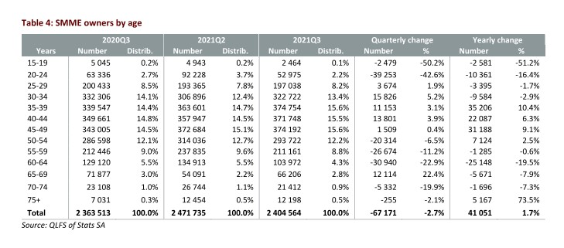

STELLA NDABENI-ABRAHAMS
MINISTER: SMALL BUSINESS DEVELOPMENT

