

**MINISTRY OF TOURISM**

**REPUBLIC OF SOUTH AFRICA**

Private Bag X424, Pretoria, 0001, South Africa. Tel. (+27 12) 444 6780, Fax (+27 12) 444 7027

Private Bag X9154, Cape Town, 8000, South Africa. Tel. (+27 21) 469 5800, Fax: (+27 21) 465 3216

**NATIONAL ASSEMBLY:**

**QUESTION FOR WRITTEN REPLY:**

**Question Number: 238**

**Date of Publication: 12 July 2019**

**NA IQP Number: 4**

**Date of reply: 2019**

**Mr G R Krumbock (DA) to ask the Minister of Tourism:**

(a) What are the monthly statistics of international tourist arrivals in the past three years and since 1 January 2019 to date, (b) where did these international tourists arrive in each month, (c) what targets were set, (d) how did the targets measure up to actual arrivals in each month and (e)(i) what is being done to ensure that targets set are met and (ii) how is this measured? NW1197E

**Reply**

1. **Monthly statistics of international tourist arrivals in the past three years and since 1 January 2019 to date**



Source: Statistics SA, P0351 Tourism & Migration Monthly reports

1. **Where did these international tourists arrive in each month?**



Source: Statistics SA, P0351 Tourism & Migration Monthly reports



Source: Statistics SA, P0351 Tourism & Migration Monthly reports



Source: Statistics SA, P0351 Tourism & Migration Monthly reports



Source: Statistics SA, P0351 Tourism & Migration Monthly reports

1. **What targets were set?**

Targets are set on a quarterly basis and are detailed in the table below responding to question d).

1. **How did the targets measure up to actual arrivals in each month?**

Measured since the 5 in 5 strategy was implemented

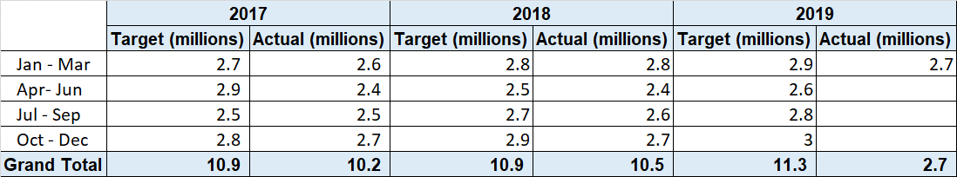

Source: South African Tourism Annual Performance Plan 2019-20; Statistics SA, P0351 Tourism & Migration Monthly reports

1. **(i) What is being done to ensure that targets set are met?**

South African Tourism has developed a recovery plan to ensure we meet our targets. The plan looks at areas that require intensive focus to turn around the current performance. The areas of focus were determined through an analysis of markets that have not been performing as expected and has negatively impacted performance relative to targets. The analysis also identified markets that are showing opportunity for increased growth and these need to be exploited. The recovery plan identifies six points to focus on to achieve the aggressive growth needed to meet the targets. The 6-points are:

1. Focus on prioritized markets and segments which includes India, China, Nigeria, USA, UK, Germany and Australia
2. Craft a brand campaign to improve top of mind awareness
3. Driving Conversion through partnerships with trade
4. Enhanced focus on Domestic Tourism
5. Industry partnerships
6. Intergovernmental relationships

(ii**) how is this measured?**

Performance is measured through the tourist arrivals statistics as reported monthly by Statistics SA through the report P0351 Tourism & Migration.