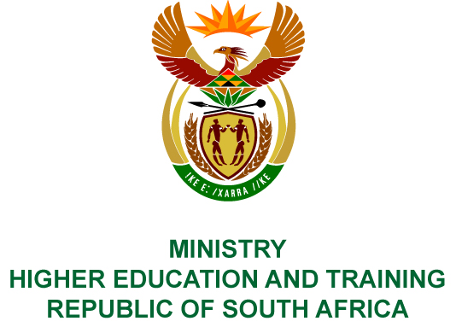
Private Bag X893, Pretoria, 0001, Tel (012) 312 5555, Fax (012) 323 5618
Private Bag X9192, Cape Town, 8000, Tel (021) 469 5150, Fax: (021) 465 7956
Memorandum from the Parliamentary Office
NATIONAL ASSEMBLY
FOR WRITTEN REPLY
QUESTION 2379
DATE OF PUBLICATION OF INTERNAL QUESTION PAPER: 24/08/2018
(INTERNAL QUESTION PAPER NO 26 OF 2018)
Ms N Nolutshungu (EFF) to ask the Minister of Higher Education and Training:
Whether she intends to support a presidential pardon for the convicted Fees Must Fall activists since the Government has agreed to the principle that education must be free?
NO2611E
REPLY:
There is no provision in the relevant laws and regulations which allows for intervention or support by Ministers in the processing of Presidential pardons.

