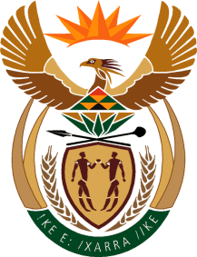

MINISTRY OF TOURISM
REPUBLIC OF SOUTH AFRICA

Private Bag X424, Pretoria, 0001, South Africa. Tel. (+27 12) 444 6780, Fax (+27 12) 444 7027
Private Bag X9154, Cape Town, 8000, South Africa. Tel. (+27 21) 469 5800, Fax: (+27 21) 465 3216

Ref: TM 2/1/1/10

NATIONAL ASSEMBLY:

QUESTION FOR WRITTEN REPLY:
Question Number: 2374
Date of Publication: 18 August 2017
NA IQP Number: 28
Date of reply: 7 September 2017

Mr J Vos (DA) to ask the Minister of Tourism

With reference to the recent use of an image of the City of Auckland to promote the City of eThekwini Metropolitan Municipality by South African Tourism (SAT), what mechanisms have been put in place by (a) SAT and (b) her department to (i) ensure consistent and competent marketing of major cities and (ii) co-ordinate major city marketing to align with SAT’s overall marketing strategy? NW2621E

Reply:
Mechanisms put in place by:
- South African Tourism (SAT) to:
- SA Tourism has created a digital asset library with approved images, films and a destination presentation that considers all the provinces for Provinces and various stakeholders to use.

- SA Tourism provides a Corporate Identity Manual to guide the SA Tourism brand and images to be used. SA Tourism has further included this in the pending performance agreements with the Provinces.

- Department of Tourism to:
- - (ii) Not applicable, the destination marketing mandate is with South Africa Tourism.

