

**MINISTRY**

**STATE SECURITY**

**REPUBLIC OF SOUTH AFRICA**

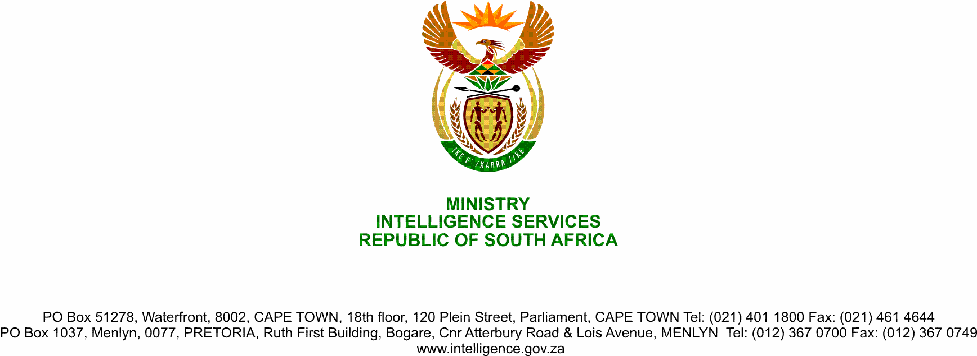

**NATIONAL ASSEMBLY**

**QUESTION FOR WRITTEN REPLY**

**QUESTION NO.:** **2370.**

**Ms D Kohler (DA) to ask the Minister of State Security:**

(1) Whether, in relation to the recommendations of the High-level Review Panel into the State Security Agency, there has been an investigation into and a report produced on the involvement of members of the Executive in intelligence operations and measures to prevent this; if so, (a) which members of the national Executive exceeded their mandate in this regard and (b) what consequences have they faced;

(2) whether, in relation to the recommendations of the High-level Review Panel into the State Security Agency, there has been an investigation into and a report produced on the policy framework including legislation that governs operational activities conducted by members of the national Executive; if not, why not; if so, what are the relevant details;

(3) whether, in relation to the recommendations of the High-level Review Panel into the State Security Agency, there has been an investigation into and a report produced on the development of guidelines that will enable members to report a manifestly illegal order as envisaged in section 199(6) of the Constitution of the Republic of South Africa, 1996; if not, why not, if so, what are the relevant details;

(4) whether, in relation to the recommendations of the High-level Review Panel into the State Security Agency, there has been an investigation into and a report produced on the effectiveness of (a) Training and Development Programmes in capacitating members of the Agency and (b) intelligence and counter-intelligence coordination within the Agency and between the agency and other South African intelligence entities and the capacity and role of the National Intelligence Coordinating Committee in this regard; if not, what is the position in this regard; if so, what are the relevant details;

(5) whether, in relation to the recommendations of the High-level Review Panel into the State Security Agency, there has been an investigation into and a report produced on the effectiveness and appropriateness of the existing oversight mechanisms in ensuring accountability and transparency; if not, what is the position in this regard; if so, what are the further relevant details? NW2945E

**REPLY**

(1) Yes. Investigations have been instituted. These investigations are on going.

(2) The Constitution of the Republic of South Africa prohibts involvement of the Members of the Executive into the intelligence operations of the State Security Agency (SSA). Furthermore, the existing National Strategic Intelligence Act (Act 39 of 1994) and Operational Directives of the SSA also prohits involvement of the Members of the Executive into the intelligence operations.

Both the National Strategic Intelligence Act (Act 39 of 1994) and the Intelligence Services Act (Act 65 of 2002) are under review for amendment as part of the intelligence reforms recommended by the High-level Review Panel.

(3) Review of Operational Directives and Standard Operational Procedure is a work in progress. The review seeks to amongst others enable SSA Members to report manifestly illegal order. Furthermore, a process on Amendments to Regulations is currently underway, the Regulations will strengthen accountability and good governance of the Members.

(4) The Intelligence Academy is in a process of reviewing its training programmes with a view to adequately capacitate Members of the intelligence community. Furthermore, the intelligence amendments currently underway seeks to improve coordination of intellligence and counter intelligence.

(5) The Reports are instrumental in the reform and the legislative amendments, aimed at strengthen the oversight structures. The legislative amendments will be submitted to Parliament for consideration, inputs and processing.