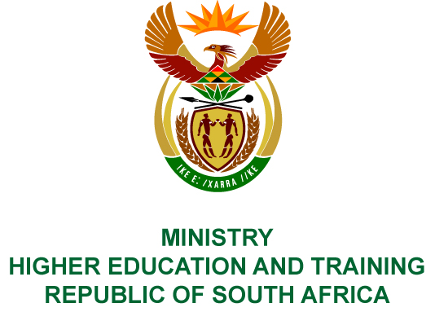
Private Bag X893, Pretoria, 0001, Tel (012) 312 5555, Fax (012) 323 5618
Private Bag X9192, Cape Town, 8000, Tel (021) 469 5150, Fax: (021) 465 7956
Memorandum from the Parliamentary Office
NATIONAL ASSEMBLY
FOR WRITTEN REPLY
QUESTION 2370
DATE OF PUBLICATION OF INTERNAL QUESTION PAPER: 17/08/2018
(INTERNAL QUESTION PAPER NO 23 OF 2018)
Ms S Mchunu (ANC) to ask the Minister of Higher Education and Training:
In view of the recent 6th BRICS Education Ministers’ meeting that was held in Cape Town recently under the theme Deepening BRICS Education Partnerships and Exchanges, where the Ministers reflected on the successes and challenges related to earlier education commitments made by the BRICS countries, how has she found the reflections made by the BRICS partners on university partnerships, technical and vocational education and training, work-based learning and digitisation can assist in strengthening the country’s post-school education and training system?
NW2548E
REPLY:
The Department hosted the 6th BRICS Education Ministers Meeting on 10 July 2018 under the theme “Deepening BRICS Education Partnerships and Exchanges”. The meeting aimed to reflect on the successes and challenges related to earlier education commitments made by the BRICS countries. The meeting ensured the exchange of best practices to improve education and training systems as well as pursuing opportunities for skills development.
Collaboration in higher education and training with BRICS countries is based on mutual learning and knowledge sharing. The cooperation facilitates the exchange of skills, expertise and knowledge between BRICS countries and various agencies in the education system to build long-term relations of mutual benefit. BRICS cooperation also promotes system-to-system cooperation whereby policymakers, institutions, academics and students have access to relevant, high-quality international practices, research, experiences and expertise.
The meeting reflected on how Workplace-Based Learning can support improved learning and employability and shared their best practice models. The meeting also highlighted the importance to develop innovative approaches to vocational education provision, guaranteeing workforce integration into the future labour market and consequently, increase economic productivity and social inclusion.
The meeting also discussed experiences on digitisation where India developed a massive Open Online Course platform known as the SWAYAM (Study Webs of Active – Learning for Young Aspiring Minds). This is a holistic learning platform, which can be accessed anytime. It comes in an e-Content self-instructional material, e-Books, illustrations, case studies and presentations.
This experience together with international research strongly suggest that in pursuing the shift towards an open learning orientation will also encourage the post-school sector towards taking on board evident changes in the way a new generation of learners are beginning to view learning, education and training as well as how they are using technology in teaching and learning.
The meeting noted that Technical and Vocational Education and Training (TVET) provision has a direct role in supporting the skills needs of industry, and the employment and career needs of workers, however, TVET- industry partnerships in South Africa have been weak. The BRICS platform will assist members in positioning TVET in a way that not only addresses the skills sets required to improve productivity and economic growth but also to reduce poverty and inequality in society. As such, workers need to have both general and more defined skill sets, with the capacity to adapt these skill sets in the face of evolving industry demands.
The interaction was aimed at promoting university partnerships with the need to strengthen academic exchange and student mobility among the BRICS member states. A representative of the BRICS Network University indicated that successful collaboration of the BRICS universities on research and teaching, student and staff exchanges is already a significant contribution to global knowledge production. South Africa is already receiving scholarship offers from BRICS countries and have students studying in China, Russia and India. Negotiations are underway way with Brazil.
Through its teaching partnerships, the BRICS Network University will promote academic programmes that produce the kind of graduates that can lead the BRICS societies into the future. The thematic areas for the BRICS Network University, i.e. energy, information security, climate change, water resources and pollution treatment have been carefully selected to exploit the knowledge strengths of the BRICS member states.
The work of the BRICS Network University is in alignment with that which the post-school education and training system is aiming to accomplish; that is to build a stronger and more cooperative relationship between education and training institutions and the workplace. BRICS gives a real opportunity for effective learning and knowledge diplomacy to make a difference to the lives of its citizens.
The BRICS Education Ministers meeting resulted in the signing of a joint declaration with tangible outcomes in different areas. Brazil offered to host a workshop on innovation among TVET institutions in BRICS countries. India offered to develop a proposal, which will focus on e-learning across BRICS countries, and share best practices, South Africa offered to develop a doctoral BRICS Network Programme, and lastly, Russia offered to put together a proposal for the establishment of a coordinating process for the BRICS Network University.

