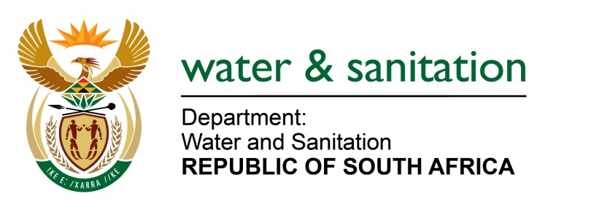

NATIONAL ASSEMBLY

FOR WRITTEN REPLY

QUESTION NO 2370

DATE OF PUBLICATION IN INTERNAL QUESTION PAPER: 19 JUNE 2015
(INTERNAL QUESTION PAPER NO. 22)

2370. Ms T E Baker (DA) to ask the Minister of Water and Sanitation:

(1) With reference to Rand Water’s appointment as water service provider to the Bushbuckridge Local Municipality in the 2013-14 financial year, how many (a) villages had water at the time of the takeover and (b) more villages have received water since the appointment of Rand Water;

(2) what is the status of phase one of the reticulation project;

(3) what are the reasons for the escalation in the cost of implementation of phase one from R121 million to R278 million as per council reports;

(4) what has been the progress of the reticulation project from the 2013-14 to 2014-15 financial years? NW2734E
---00O00---

REPLY:

(1)(a) According to Census 2011, 11,9% of the population in Bushbuckridge had access to piped water in their dwellings, the remaining was supplied with water at Reconstruction and Development Programme (RDP) standard (i.e Boreholes/communal taps) and Water Carts.

(1)(b) A total of 24 villages have received water since the appointment of Rand Water.

(2) All projects which were implemented under Phase 1 to reticulate 24 villages in Bushbuckridge were completed.

(3) Initially, the scope of the work was under estimated, upon assessment and finalization of technical designs of the projects, it was discovered that bulk of the work was not included in the initial scope of the work, therefore additional budget was required to complete the projects.

(4) The intervention was initiated in the 2013/14 financial year, 24 villages were completed in the 2014/15 financial year and a further
15 villages are currently being reticulated.

---00O00---

