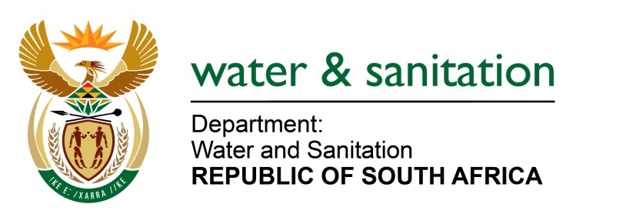

NATIONAL ASSEMBLY

FOR WRITTEN REPLY

QUESTION NO 237

DATE OF PUBLICATION IN INTERNAL QUESTION PAPER: 17 FEBRUARY 2017
(INTERNAL QUESTION PAPER NO. 2)

237. Mrs K Jooste (DA) to ask the Minister of Water and Sanitation:
Is there a maintenance plan to ensure that the water pipes in the (a) Buurendaal, (b) Highway Gardens, (c) Harmelia, (d) Tunney, (e) Elandsfontein and (f) Klopper Park suburbs in the Ekurhuleni Metropolitan Municipality in Gauteng specified suburbs are regularly maintained; if not, are the specified water pipes only repaired when there is a burst water pipe; if so, how often are the water pipes maintained? NW254E
---00O00---
REPLY:

The following information was provided to My Department by the Municipality.
Ekurhuleni Metropolitan Municipality has a system of annual maintenance plans for all pipelines. The maintenance plans are used for scheduling all required maintenance. This is backed by a monitoring system which tracks time lines for repairing and replacing of burst and leaking water pipes. Ekurhuleni Metropolitan Municipality has a turnaround time of 48 hours to fix burst water and leaking water pipes. To ensure customer satisfaction, Ekurhuleni Metropolitan Municipality uses a Customer Relationship Management System, which monitors and tracks the reported cases.
In an effort to increase water supply to its consumers, Ekurhuleni Metropolitan Municipality treats every burst and leaking water pipe in a serious light. During early 2015, Ekurhuleni Metropolitan Municipality established a Rapid Response Unit, which its sole function is to address water losses within the Municipality areas, including the suburbs of (a) Buurendaal, (b) Highway Gardens, (c) Harmelia, (d) Tunney, (e) Elandsfontein and (f) Klopper Park.
---00O00---

