

**MINISTRY**

**STATE SECURITY**

**REPUBLIC OF SOUTH AFRICA**

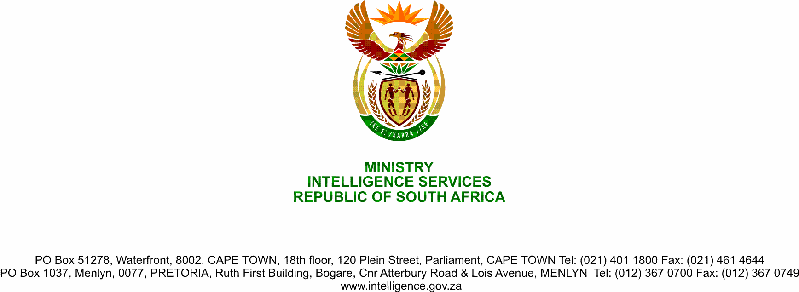

**NATIONAL ASSEMBLY**

**QUESTION FOR WRITTEN REPLY**

**QUESTION NO.:** **2369.**

**Ms D Kohler (DA) to ask the Minister of State Security:**

Whether, in relation to the recommendations of the High-level Review Panel into the State Security Agency, there has been an investigation into and a report on the (a) impact on the work of the civilian intelligence agencies of the amalgamation of the previous services into one agency and the appropriateness of the change, (b) appropriateness of the current structure of the agency to its core mandates and to effective command, control and accountability, (c) mandate and capacity of the State Security Agency (SSA) and to examine the compatibility of its structure in relation to this mandate, (d) effectiveness of controls to ensure accountability and (e) institutional culture, morale, systems and capacity to deliver on the mandate; if not, in each case, why not; if so, what are the relevant details in each case?

NW2944E

**REPLY**

All the matters raised above by the Honourable Member of Parliament have extensively been dealt with in the Findings and Recommendations of the High-Level Review Panel, particularly as outlined in Chapters 3, 4, 5, 6, 7, 8, 12 and 13 of the High-Level Review Panel’s Report. These matters therefore do not require additional investigation as doing so would duplicate the work done by the Panel. The Honourable Member is also reminded that the President of the Republic, HE President MC Ramaphosa, accepted the High-Level Review Panel report with all its findings and recommendations.

Processes such as drafting of a new legislative framework and the review of internal departmental regulatory processes have been initiated to address the implementation of the recommendations and these are at various degrees of development and implementation. Some of the recommendations in relation to capacity, etc., are however dependent on the finalisation of a new legislative framework.