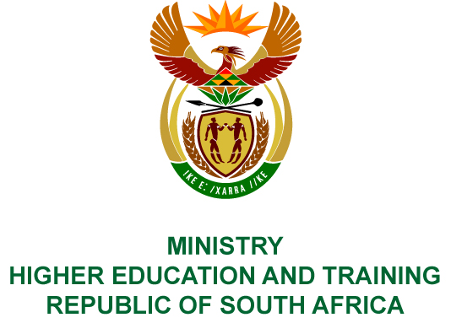
Private Bag X893, Pretoria, 0001, Tel (012) 312 5555, Fax (012) 323 5618
Private Bag X9192, Cape Town, 8000, Tel (021) 469 5150, Fax: (021) 465 7956
Memorandum from the Parliamentary Office
NATIONAL ASSEMBLY
FOR WRITTEN REPLY
QUESTION 2367
DATE OF PUBLICATION OF INTERNAL QUESTION PAPER: 17/08/2018
(INTERNAL QUESTION PAPER NO 23 OF 2018)
Mr M J Wolmarans (ANC) to ask the Minister of Higher Education and Training:
With reference to the SA Human Rights Commission Report on Transformation at Universities which recommended that her department takes a leading role in the transformation of institutions of higher learning and that universities should report annually on their state of transformation, what work has been put in to address recommendations which have not yet been addressed?
NW2545E
REPLY:
In 2014, the Department of Higher Education and Training (DHET) promulgated
the revised Regulations for Reporting by Public Higher Education Institutions
(R464, Government Gazette No. 37726 of 9 June 2014) which impose a duty on all university councils to report on transformation in their annual reports. In terms of the Regulations, public higher education institutions are required to adopt, implement and report on policies that promote transformation in their respective institutions. This report on transformation must clearly indicate initiatives that seek to advance people from historically disadvantaged backgrounds, women and people with disabilities. It should also indicate any transformation measures implemented with regard to teaching, learning and research activities. In addition, public higher education institutions are required to monitor the effectiveness and impact of policies implemented to address transformation in their respective institutions. All this information must be submitted to the Department annually.
Upon receipt of the South African Human Rights Commission’s report in December 2016, the Department circulated the report to all University Vice-Chancellors for their consideration and action. Universities were requested to respond to the report by submitting their implementation plans to the Department in which they demonstrate how they intend giving effect to the recommendations outlined in the report, including the resolutions of the 2015 Higher Education Transformation Summit held in Durban in October 2015.
The Ministerial Committee on Transformation in Public Universities (TOC) has conducted an analysis of both Universities’ annual transformation reports as well as the transformation implementation plans, and it is currently in the process of compiling a report on the state of transformation in the higher education system. The envisaged report will identify barriers to substantive transformation in the sector, and will include recommendations to the Minister on appropriate interventions and initiatives to be effected in order to accelerate the pace of transformation in the sector.
Subsequent to its appointment in July 2017, the TOC developed and is currently implementing a three-year action plan which is informed by, among others, the recommendations of the SAHRC report. The TOC’s primary mandate is to monitor transformation in the sector and to advise the Minister on appropriate policies and other interventions required to accelerate transformation of the higher education sector. The Department and the TOC hold regular meetings with Universities South Africa which represents all twenty-six (26) public Universities, with the intention of addressing transformation challenges confronting the sector and to collaborate on sectoral transformation activities.

