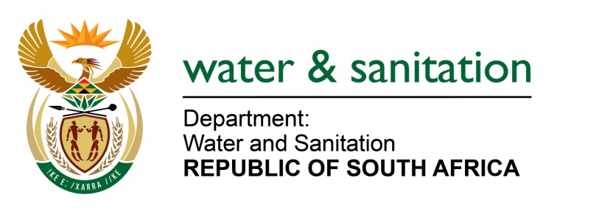

NATIONAL ASSEMBLY

FOR WRITTEN REPLY

QUESTION NO 2367

DATE OF PUBLICATION IN INTERNAL QUESTION PAPER: 19 JUNE 2015
(INTERNAL QUESTION PAPER NO. 22)

2367. Mr L J Basson (DA) to ask the Minister of Water and Sanitation:

(1) Whether the cyanobacteria is present in the (a) Hartebeespoort Dam, (b) Vaal Dam, (c) Spitskop Dam, (d) Barberspan, (e) Koppies Dam and (f) Chrissiesmeer; if so, what are the relevant details;

(2) whether she can provide the results of each of the water tests done at each of the specified dams since 1 January 2011; if not, why not; if so, what are the results in each case;

(3) whether she has taken any steps to resolve the problem of the presence of cyanobacteria in the specified dams; if not, why not; if so, what are the relevant details;

(4) what danger does the bacteria cyanobacteria pose to standing water bodies? NW2731E
---00O00---
REPLY:
- The Department does not currently monitor Barberspan or Chrissiesmeer for cyanobacteria, as they do not form part of the National Eutrophication Monitoring Programme (focused on dams). Both Barberspan and Chrissiesmeer are viewed as wetlands and will form part of the National Wetlands Monitoring Programme, which is currently being designed and will be implemented in 2016. For the other dams, the most recently available cyanobacterial counts are listed in the table below:

Dam | Cyanobacterial count (cells/ml)  (including Anabeana, Arthrospira, Cylindrospermopsis, Lyngbya, Merismopedia, Microcystis and Oscillatoria
Hartbeespoort | 22 342
Vaal | 33 524
Spitskop | 7 851
Koppies | Not available

- Results can be provided for all the dams since 2011 as requested, except Barberspan and Chrissiesmeer. The data information can be viewed on the Directorate’s website - https://www.dwa.gov.za/iwqs.
- Addressing cyanobacteria in dams requires a multidisciplinary approach with its foundation in catchment management. Nutrient loading resulting from run-off in catchment where the dam is located, is the main reason for cyanobacterial blooms.

This loading takes place as a result of, inter alia, overloaded and / or dysfunctional waste water treatment works and agricultural run-off. DWS addresses this through collaboration with and guidance to local authorities, whom is responsible for operating these waste water treatment works. The Green Drop project is an example of this, where the efficient operation of wastewater treatment works by municipalities is audited and scored. Based on the outcome of this evaluation, guidance is provided by the Department of Water and Sanitation (DWS) to municipalities to assist them with adhering to the license conditions of the waste water treatment works.

The DWS has also recently acquired the services of Cuban engineers to assist local municipalities with the improved operation of their waste water treatment works.

The Department developed a set of guidelines for eutrophication management, including best agricultural practices which, if implemented by farmers, will reduce the nutrient loading resulting from agricultural run-off.

A specific project on the Hartbeespoort Dam to address the water quality remediation, which includes the treatment of cyanobacterial blooms, is the Metsi a Me project. This is a multidisciplinary project which addresses the remediation of dam specific water quality.

There is currently no similar scale projects on the other dams mentioned in the question, as these dams’ issues are addressed on a catchment base.

(4) Cyanobacteria, when present in high numbers in the water column, and under conducive environmental conditions, can release a toxin, microcystin, which could pose a health risk if untreated water is consumed by humans and animals. In addition, when the algal blooms die off and decompose, it can result in unpleasant smells, impacting on recreational users.
---00O00---

